The Gristmill Gazette
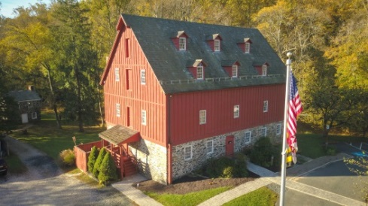
Jerusalem Mill Village
News & Notes
Spring 2019

2811 Jerusalem Rd., Kingsville, MD www.jerusalemmill.org 410-877-3560

Upcoming Events

All activities are in the village, unless otherwise indicated.

April 6th – Friends of Jerusalem Mill Spring Dinner and auction, 6 PM to 9:30 PM, Richardson Farms, 5900 Ebenezer Rd., White Marsh. $$ Tickets will NOT be sold at the door. For more information call Pat Martin, 410-638-5432.

April 6th – Project Clean Stream, 10 AM to
1 PM. Gunpowder Falls State Park, Jones Road parking lot and trail, 10400 Jones Road, Kingsville MD. Rain or shine! Trash bags, trash pickers and gloves will be provided.

April 13th – Second Saturday Serve volunteer day, 9 AM until noon. All volunteers are welcome.

April 14th – Easter Egg Roll (an old- fashioned American tradition), 1 PM to
4 PM. The Easter Bunny will be there! There will be indoor activities in the Visitor’s Center if it rains. See full-page notice on page 9.

April 20th – Cancer and Research Education (C.A.R.E.) 5K walk/run, 10 AM.

May 11th – Second Saturday Serve volunteer day, 9 AM until noon. All volunteers are welcome.

May 18th - Harry Brooks Memorial Tournament (Jousting), 11 AM.
May 27th – Amy’s Memorial Ride. 8:30 AM. Registration starts at 7:30 AM. See article on page 7.

June 1st – Private event in the meadow, all day.

June 8th - Founder's Day Joust, 11 AM.

June 8th – Second Saturday Serve volunteer day, 9 AM until noon. All volunteers are welcome.

June 9th – Charlie Zahm concert in the meadow, 6 PM to 8PM. Celtic and 18th and 19th century North American music. See page 6 for more details. $

June 18th – National Federation of the Blind students from around the country visit the village for demonstrations of timber frame construction.

June 22nd - George Kreutzer Memorial Joust, 11 AM.

June 22nd – Private event in the meadow, all day.

June 23rd – Kaleidoscope concert in the meadow, 6 PM to 8 PM. A wide range of R&B, classic rock, country and top 40 songs. See page 6 for more details. $

July 7th – Jerusalem Mill Yard Sale. 8 AM to 2 PM. A wide variety of items available.

Details on all of our events are available on our web page at www.jerusalemmill.org.

In the Spotlight:

Jousting by Joyce Barnett

I am one of the very grateful members of the Amateur Jousting Club of Maryland. Our club has been in existence since the summer of 1958. Several years ago, we lost our jousting field and were in desperate need of a new place to meet and practice our sport. Thanks to our friends at Jerusalem Mill we can once again enjoy the sport of jousting and share it with others. We have been warmly welcomed and allowed to joust here on the property. We have set up permanent jousting arches behind the dairy barn. We’re blessed to be able to continue to participate in this sport in such a beautiful setting surrounded by so many warm and friendly people. Like Jerusalem Mill, jousting is actually very much a part of our country’s history.
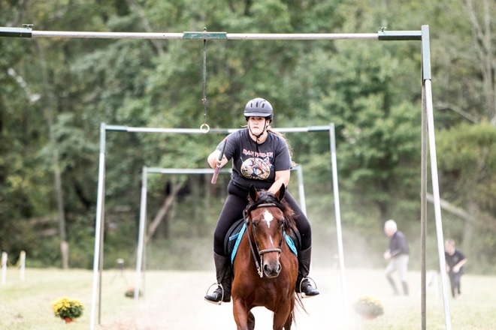
Photo courtesy of Jack Benesch

When people think of jousting they think of medieval combat on horses, which is how the sport first came about. Although it is not known exactly when jousting for rings instead of jousting against one another was first started, it was known to be practiced by James I of England. Cecil Calvert was a great fan of ring jousting and it was practiced in Maryland by the Calvert family [Editor’s note: Cecil Calvert was the 2nd Baron of Baltimore, and governed Maryland for 42 years, from his home in England]. Many ring jousts were held throughout the area over the years. They were especially popular at weddings of the wealthy. It is said that one of the Ridgelys of Hampton Mansion had a joust on the front lawn for his daughter’s wedding. However, jousting did not remain for the wealthy only. After the civil war, jousting tournaments were held to raise money to rebuild the south. Often churches would sponsor a joust on their grounds and local farmers would come to compete. People would come from all around to watch the tournaments. Many jousting tournaments today are sponsored by churches in conjunction with their annual fairs or festivals. In Feb. 1962, Honorable Henry J. Fowler Sr., delegate from St. Mary’s County, introduced a bill into the Maryland House of Delegates giving recognition to jousting as the official state sport of Maryland. The bill was quickly passed and signed into law making Maryland the first state in the country to have a state sport.
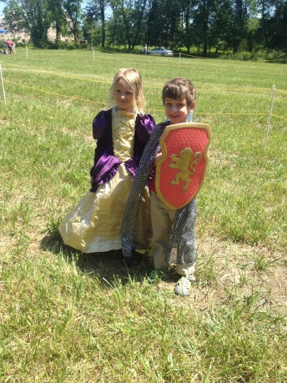
Today jousting is a sport which is enjoyed by all types of people. It is still a contest of horse-manship, but it is enjoyed by people from all walks of life. Everyone competes under the same rules. The classes are separated by ability. There may be children competing against adults of the same ability and men competing against women. Often it is a family affair and you may have several generations of riders from the same family competing. Pictured are Sara and Luke, the next generation of jousters.
We love spectators at our jousts. As a spectator at one of today’s jousting tournaments you will see several skill levels of jousting. There is the leadline class which is our future jousters (usually children still learning to ride), the novice or beginner class, the amateur class, the semi- professional, and the professional class. Except for the Novice class, which is not timed, all competitors must gallop down an 80 yard track in under 9 seconds while attempting to spear small rings on a lance. The size of the rings depends on the class. The rings range in size from 1 ¾ “ for the Novice class to 1” for the professional class. The size of the rings is reduced in the event of a tie, so it can get exciting. We also put on a dress parade, usually at the start of the tournament, where our participants dress in medieval attire to pay tribute to the sport’s beginnings. Please come join us this summer at one of the jousting tournaments at Jerusalem Mill. We will be here on: May 18th; June 8th; June 22nd; July 20th; and Sept. 5th, weather permitting. Please check our Facebook page at Amateur Jousting Club of Maryland for schedule updates and additional information.
[About the author: Joyce began jousting 45 years ago, and has made it a family affair since her husband, two daughters, and now her grandson have also enjoyed the sport. Joyce says “It has been a great family sport we all enjoy very much. The friendly competition, pageantry and festive atmosphere keep us coming back.”]

The jousting field is located behind the preservation award-winning Jericho Road stone Bank Barn.

Jerusalem Mill Receives Another Award

The Harford County Historic Preservation Commission, in conjunction with the Department of Planning and Zoning, has selected the Friends of Jerusalem Mill to receive its 2019 Preservation Project Award for our continuing restoration of the Jericho Road Bank Barn, which we featured in our Winter 2018 Gristmill Gazette. The Historic Preservation Awards were started in 1995 to honor excellence in historic preservation within Harford County. The biennial Preservation Project Award recognizes significant achievements in preservation to include projects “that can protect the County’s historic and scenic rural land-scapes, or projects that generally advance the practice of historic preservation within the County”. The award will be presented at a ceremony on Thursday, May 16th, at 4:30 PM at Swan Harbor Farm. If you want to attend the ceremony, please send us an e-mail at jerusalemmill@yahoo.com.

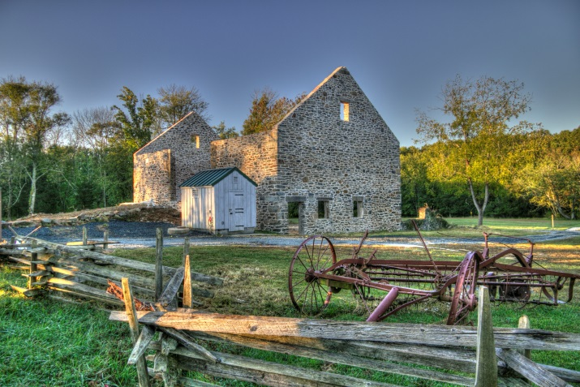
Bank Barn Photo by Jack Benesch, Sept. 2017

Partnering with the
Smithsonian Institution

If you’ve visited the Jerusalem Mill Visitor Center & Museum, you’ve probably seen our scale model grist mill, one of the more popular displays in our gallery. Designed and built by Brian Payne, and funded by the Society of Colonial Wars and the Friends of Jerusalem Mill, the model shows how the water wheels provided the power needed to turn four sets of grindstones to grind wheat into flour and corn kernels into corn meal. Our model will now become part of a traveling exhibition called Water/Ways. As described by the Maryland Humanities, “The newest traveling exhibition from the Smithsonian’s Museum on Main Street (MoMS) program, Water/Ways examines water as an environmental necessity and an important cultural element. Water impacts climate, agriculture, transportation, industry and more. It inspires art and music. Many faiths revere water as a sacred symbol. Authors and artists are inspired by the complex character of water – a substance that is seemingly soft and graceful that is yet a powerful and nearly unstoppable force. Water also plays a practical role in American society. The availability of water affected settlement and migration patterns. Access to water and control of water resources have long been a central part of political and economic planning. Human creativity and resourcefulness provide new ways of protecting water resources and renewing respect for the natural environment.”
The Water/Ways exhibit will review the crucial role of water in our lives: water as an essential biological and natural resource; sources of water; water as a connector and border; harnessing water’s power; water as a finite resource; and our relationship with water. The mill model is a great example of harnessing water’s power, in this case to facilitate the commercial production of flour and corn meal. In Jerusalem Mill village, water power was also used to power the saw mill.

Water/Ways has been made possible in Maryland by the Maryland Humanities. Water/Ways is a collaboration between the Smithsonian Institution and State Humanities Councils nationwide. Support for Museum on Main Street has been provided by the United States Congress.

From May 25th, 2019 through July 6th, 2019, The Historical Society of Baltimore County (HSBC) will be the host site for the traveling exhibit. The exhibition will not be appearing in Carroll, Cecil, Harford, Howard or Anne Arundel Counties, so if you want to see it, be sure to visit the Almshouse at HSBC, 9811 Van Buren Lane, Cockeysville, MD 21030. You’ll also see the new enhance-ments made to the mill model, showing even more details of the 1772 mill.

Specific visitor hours for the exhibit were not available in time for our publication date. You can get more information from the Historical Society of Baltimore County website as time approaches - http://www.hsobc.org/.
Special Presentation

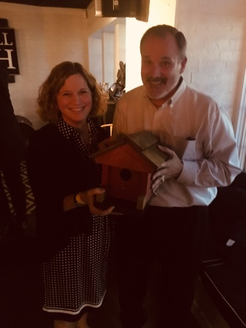
Rick Decker, President of Friends of Jerusalem Mill (FOJM), presented the Honorable Mark Belton, the outgoing Secretary of The Maryland Department of Natural Resources with a Jericho Road Covered Bridge Birdhouse at the occasion of his farewell party at Blackwall Hitch. Also in the picture is Joanne Throwe, the outgoing Deputy Secretary of the Department. Mr. Belton appreciated the historical significance of the birdhouse, made in part with reclaimed wood from the recent renovation of the Burr-Arch Covered Bridge, originally built in 1865. The birdhouse celebrates DNR’s successful partnership with the State Highway Administration, Baltimore County, Harford County, & affiliated non-profits including FOJM.
Meet Our Volunteers

Each quarter we introduce you to one of our volunteers. As a non-profit charitable organization, with no paid staff, we greatly appreciate our dedicated volunteers. We want to share their stories with you.

In this edition we’d like you to meet one of our few remaining charter members of Friends of Jerusalem Mill (FOJM), Glenn Porter. Glenn was a teacher in Harford County, where he knew fellow-teacher Harry Sanders, the FOJM founder. Glenn attended the very first meeting of the Friends at St. John’s Church, in 1985, and he’s been a part of the organization ever since. Over the years he has served as board member, Secretary, Vice-President, and President on the Board of Directors. He also helped the organization acquire its first grant, $100 from the Historical Society of Baltimore County.

Glenn says that he gets the most satisfaction out of “sharing the story of the village with interested people”. He certainly has had plenty of opportunities to do that over the past 34 years, as he has spoken to service groups, women’s clubs, the Historical Society of Baltimore County, and many school groups. For the past 20 years Glenn has headed the Education Committee, which organizes the school groups that visit the village on field trips when they are studying Colonial living or the Civil War. He and a fine group of 15 to 18 interpreters present mini-lessons on life during those time periods. Glenn and the group of volunteer interpreters have reached literally thousands of students from private, parochial and public schools, mostly from Harford and Baltimore Counties. Glenn says that “It has been very rewarding to see students, parents, and teachers enjoy the lessons in the village.”
Glenn Porter in the General Store

For the last 15 years Glenn has helped organize the general store for visitors. The building houses a Civil War Room that primarily focuses on the Confederate Cavalry raid on the store in 1864 (Gilmor’s Raid); the McCourtney Room, with various artifacts from the family of Samuel O. McCourtney, the longest serving operator of the store; and an authentically restored 1930s General Store, all offering a unique insight on village history. Over the years we have been lucky to have many dedicated volunteers help keep the store open on weekends year-round, as well as help with the many maintenance tasks.

Over the past few years Glenn and other volunteers have started a Maryland Native Plant Garden behind the store, and have added display items and signage to the nearby spring house. Glenn said that, for him, “A highlight was speaking several times with Mary Silling, McCourtney’s granddaughter, about her memories of the village. The insights and energy of visitors and volunteers alike make time spent at the village very rewarding.”

We thank Glenn greatly for 34 years of service to the Friends of Jerusalem Mill and the Jerusalem Mill Village. The General Store is open most Saturdays and Sundays from 1 to 4. Be sure to stop in and you might see Glenn! The store and Spring House hours are listed on page 10.
Summer Concert Series

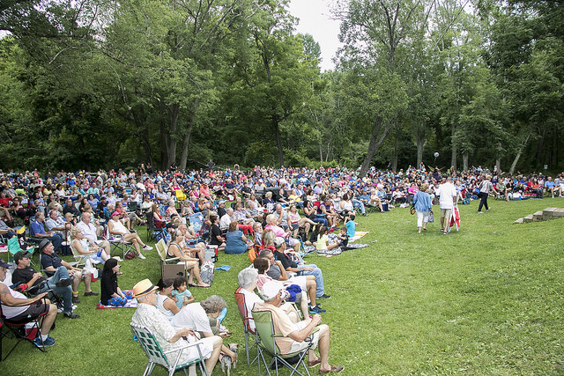

The 2019 schedule for Jerusalem Mill’s concerts in the meadow has been set:

June 9th – Charlie Zahm – One of the most popular soloists at Celtic music festivals, Maritime, and American Traditional music events anywhere east of the Mississippi. With a baritone voice some have described as “coming along once in a generation”, Charlie has become one of the most successful performers on the Celtic festival circuit, weaving magical moments of Scottish and Irish history for the listener and viewer, with a passion for the performance and a chosen repertoire pleasing to all members of the family. A master of guitar as well, Charlie brings an authentic love and respect for the music he sings – and with dashes of humor and a light in his eyes, he will draw you into the stories of his songs! Charlie also performs period North American music from the 18th and 19th centuries …

June 23rd – Kaleidoscope – A ten piece band with two guitars, bass, drums, keyboards and a three piece horn section. They play R&B, Classic Rock, some Country, and Top 40 songs. They have four male singers and one female singer so they can cover a wide range of material. They engage the audience and encourage them to be involved with the shows by dancing or by singing along with them. They try to brong a little something for everyone, no matter what age or musical interest.

July 7th – Free Range Blue – A four piece acoustic Americana band. Instrumentation includes guitar, mandolin, bass, banjo and bouzouki. With tight vocal harmonies and exceptional instrumentation, the band never fails to captivate their audience. The Free Range Blue repertoire includes folk, bluegrass, classic country, Celtic, jazz, blues and much more. They play classic tunes that you are sure to know, some obscure songs sure to become favorites, a selection of originals, and hot pickin’ instrumentals.

July 21st – Beach Bumz – A Baltimore Maryland/Orlando Florida-based beach tribute band. They perform all of the favorite beach music from Jimmy Buffet, the Beach Boys and many more of your favorite summer music classics.

August 4th – Great Train Robbery – The Kings of Classic Rock. They have entertained audiences for over 35 years, with their classic smokey southern sound. The Baltimore-based outfit has released 8 albums and played well over 5,000 shows at night clubs, colleges, festivals, fairs, and corporate events. The band is proud to have shared the stage with many well-known acts such as The Allman Brothers, Lynyrd Skynyrd, Foghat, Blue Oyster Cult, .38 Special, Marshall Tucker, BTO, Blackfoot, and many more.

All of the concerts are held in the meadow between the blacksmith shop and the Little Gunpowder Falls. The bands play from
6 PM to 8 PM (with breaks). Admission is $10 for members of the Friends of Jerusalem Mill, active military with military ID, children 12 to 15 years old, and senior citizens; $15 for non-members; children under 12 are free. Bring a blanket and/or chairs. In case of inclement weather, please check our web site for possible location change or cancellation.

The concerts are made possible through donations from our sponsors and members, and a grant from the Harford County Tourism Board and the Harford County Cultural Arts Board.

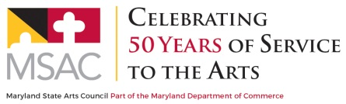
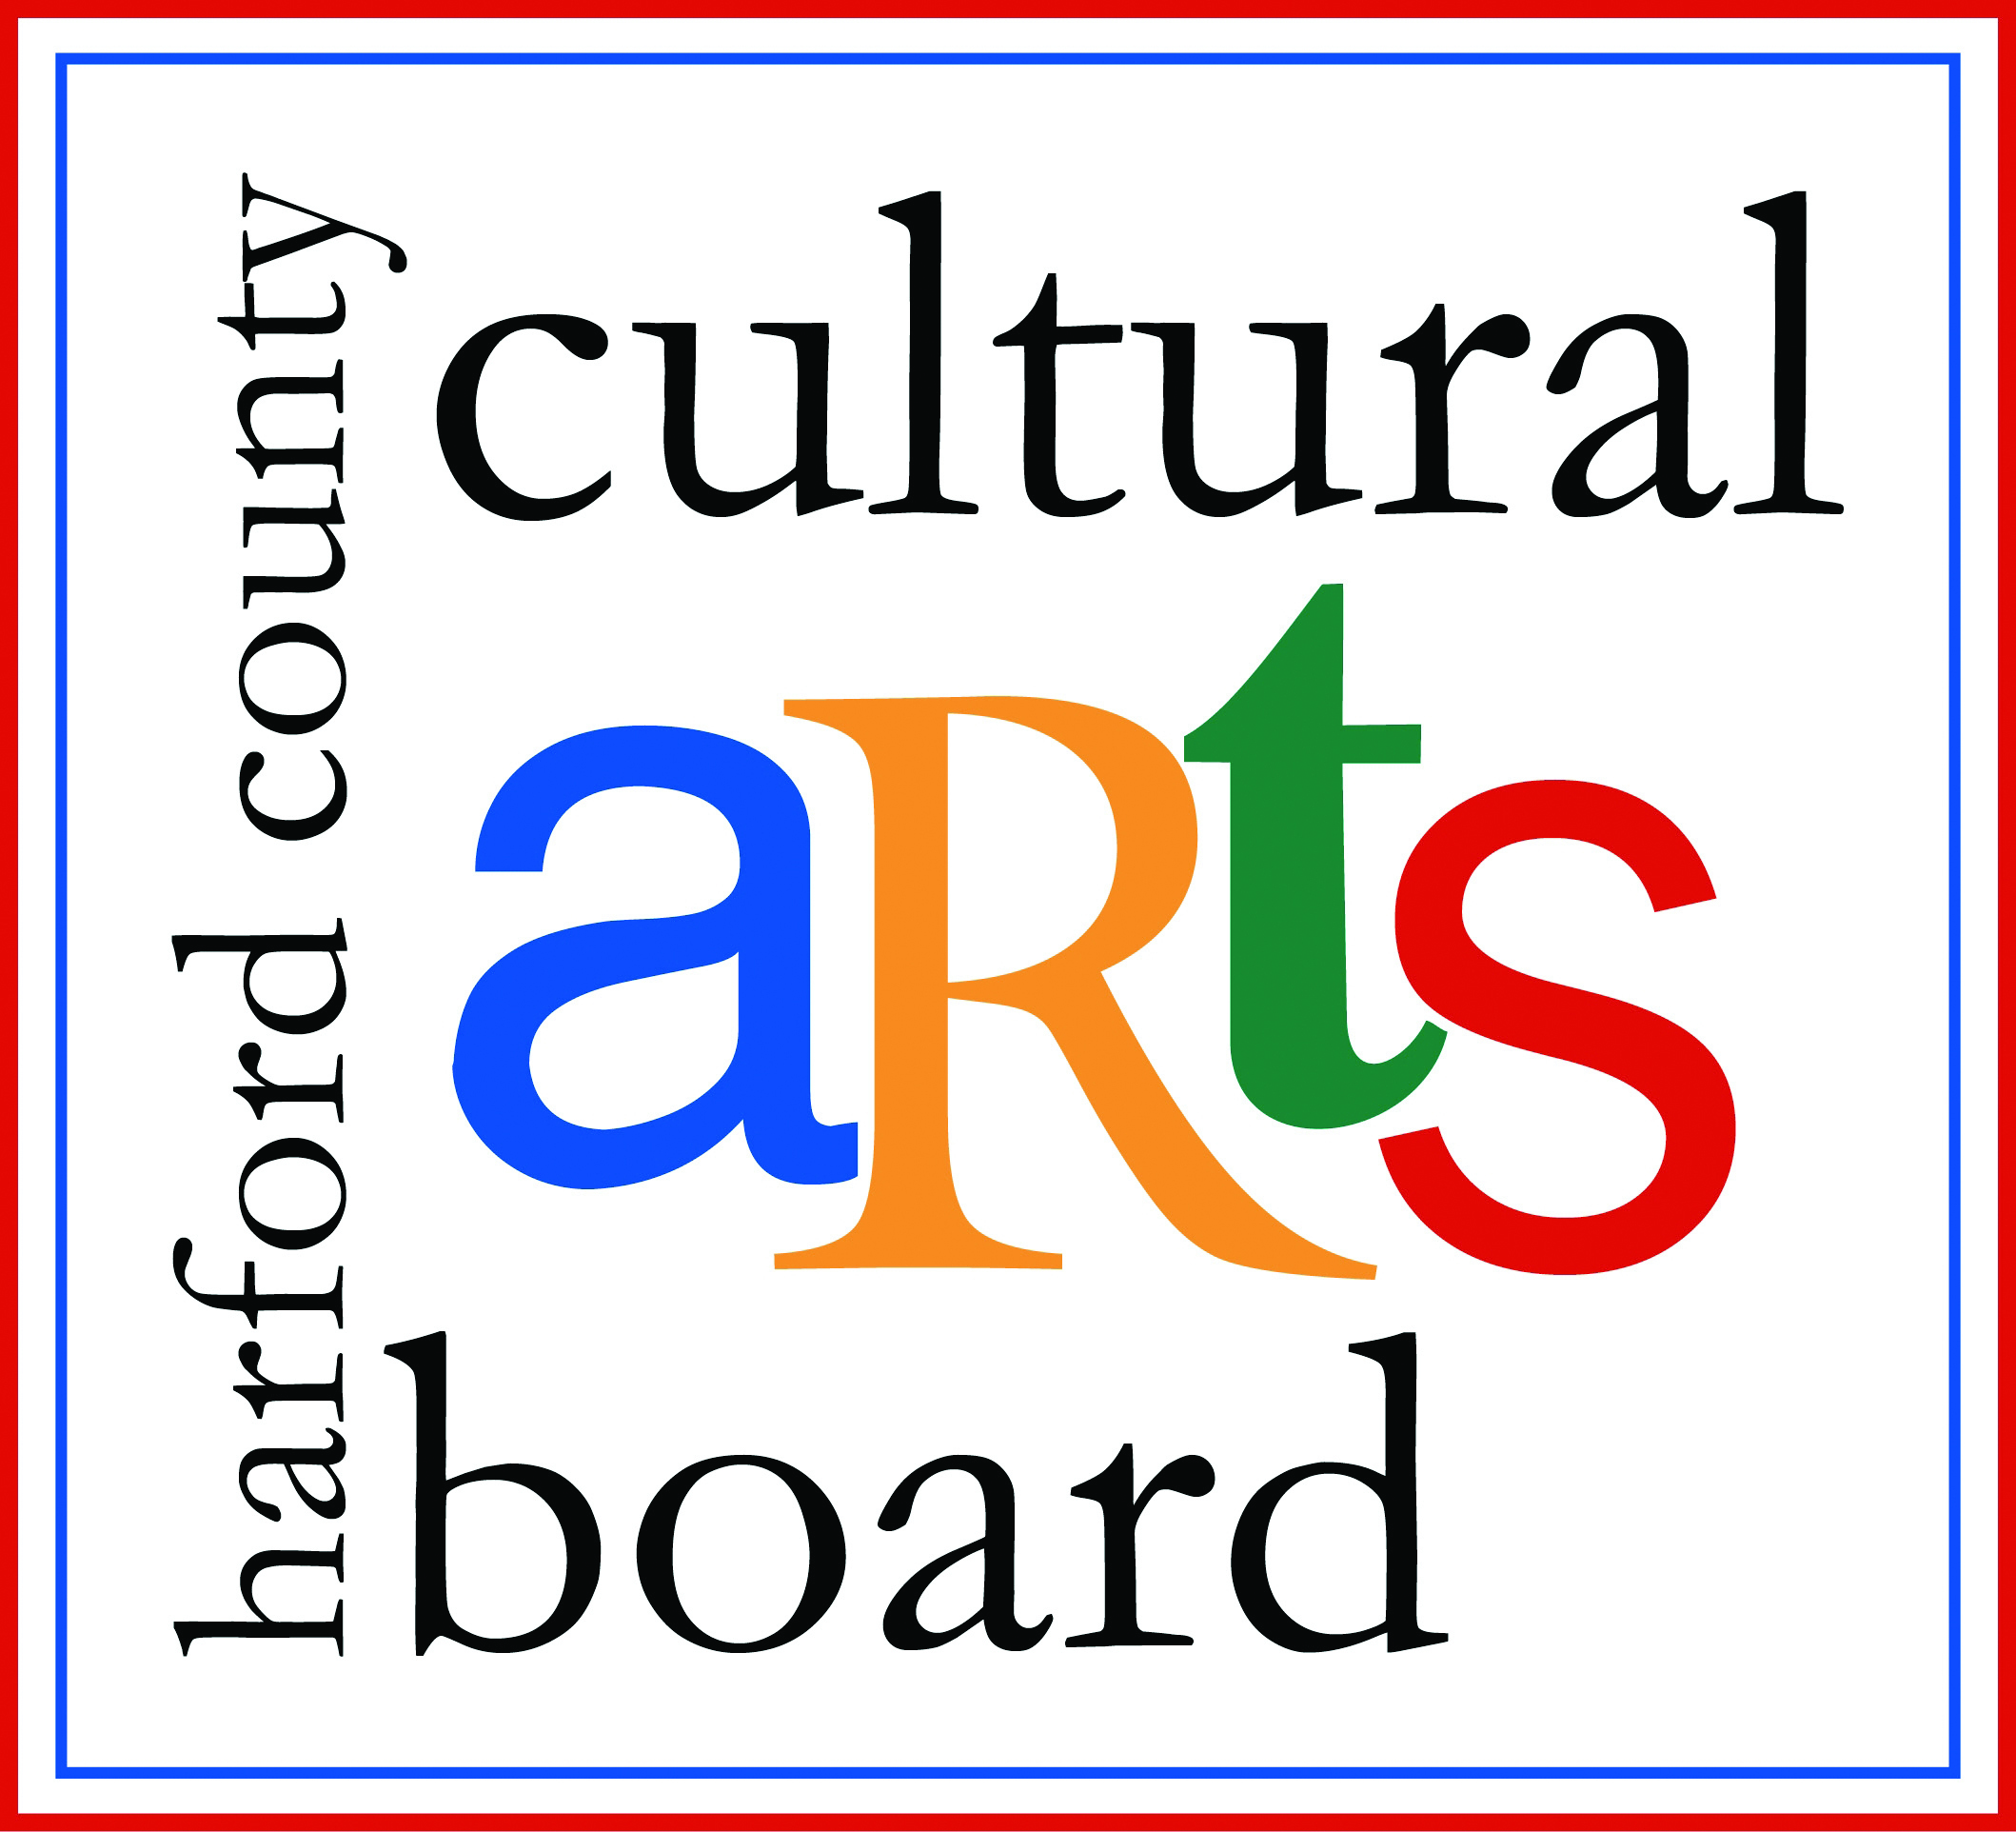
Amy’s Memorial Ride

Gunpowder United Mountain Bike Operators (GUMBO) and Friends of Jerusalem Mill will be holding the second annual Amy’s Ride and Run on Memorial Day, Monday, May 27th, which also happens to be Amy’s birthday. The event will be held at the Jerusalem Mill Village in Kingsville, MD. This year they have added the 5K memorial run in addition to the road and mountain bike rides. Registration will begin 7:30 AM, with the rides and run starting at 8:30 AM.

On the afternoon of Monday, May 21st, 2018, Officer Caprio made the ultimate sacrifice while protecting the citizens of a Perry Hall Neighborhood. Both Amy and her husband, Tim Caprio, were avid mountain bikers in the Gunpowder Area. Last year, Mr. Caprio reached out to other mountain bikers and asked if anybody would be interested in taking a ride with him in her honor. The response he received was overwhelming. Over 250 people came out in the pouring rain to show their support. While it started out as a bike ride many people commented they weren’t riding but just coming to honor our local hero. It was decided that day to continue the ride and walk every year.

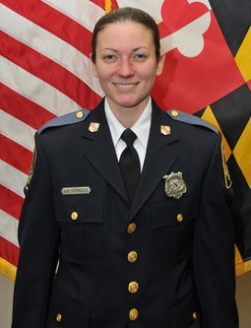

Registration before the event is highly encouraged at: https//barbellsandbadges.com/collections/
events/products/amy-s-ride-run-registration

We also invite everybody to check out the Facebook event page “2nd Annual Amy’s Ride and Run” for more details and the direct link to registration. For those that are not on Facebook you can e-mail amysmemorialride@gmail.com.
Massive Yard Sale

On Saturday, July 7th, from 8 AM to 2 PM, The Friends of Jerusalem Mill will hold its semi-annual yard sale on the village grounds, between the paved parking lot and the general store. 100% of the proceeds benefit the continued maintenance, operation, and restoration of the historic Jerusalem Mill Village. Donations of sale items will be collected until 9 AM on the day of the yard sale. Items not sold during the yard sale will be donated to one or more of the local charities.
We Need Your Help

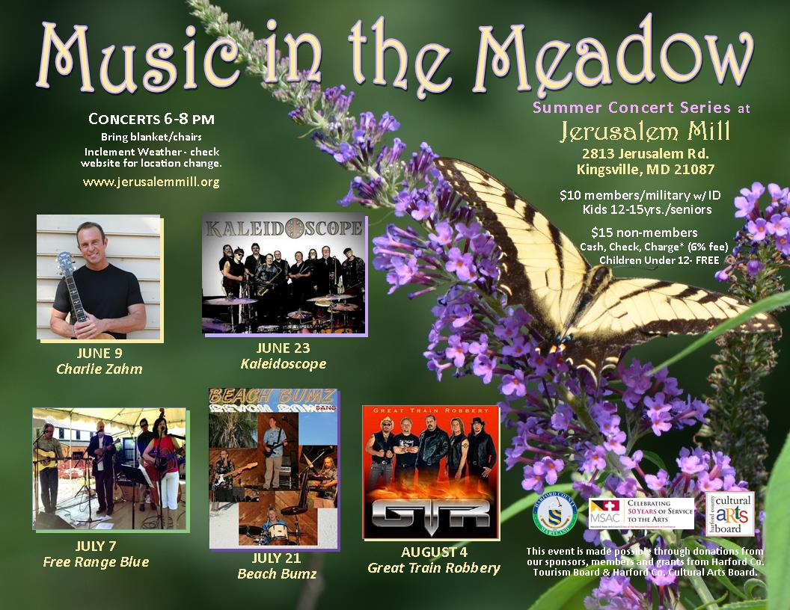
Because The Friends of Jerusalem Mill is a non-profit charitable organization, we rely on generous donations of time and money from our many volunteers and donors to accomplish our mission of preserving and presenting local history. In the coming months we will particularly need help with lawn and garden maintenance – just an hour or two each week is a help. We also need Visitor Center – Museum docents and help with organizing and staffing special events, research and curatorial assistance, period-attired interpretation, and more. Let us know if you have some time to spare and can help us continue our mission. Financial contributions can be made through membership, business sponsorship, renovation or maintenance fund contributions (cash or check), or by selecting the Friends of Jerusalem Mill as the charity of choice when you shop at AmazonSmile.com. You can get more information on all of these opportunities at www.jerusalemmill.org, or by sending your questions to jerusalemmill@yahoo.com, or call us on 410-877-3560.
To contact the newsletter editor, send an e-mail to jerusalem.mill.curator@gmail.com, or call the Visitor Center – Museum at
410-877-3560. To cancel your subscription to the Gristmill Gazette, simply send an e-mail to gristmillgazette@gmail.com with a subject line of “unsubscribe”.

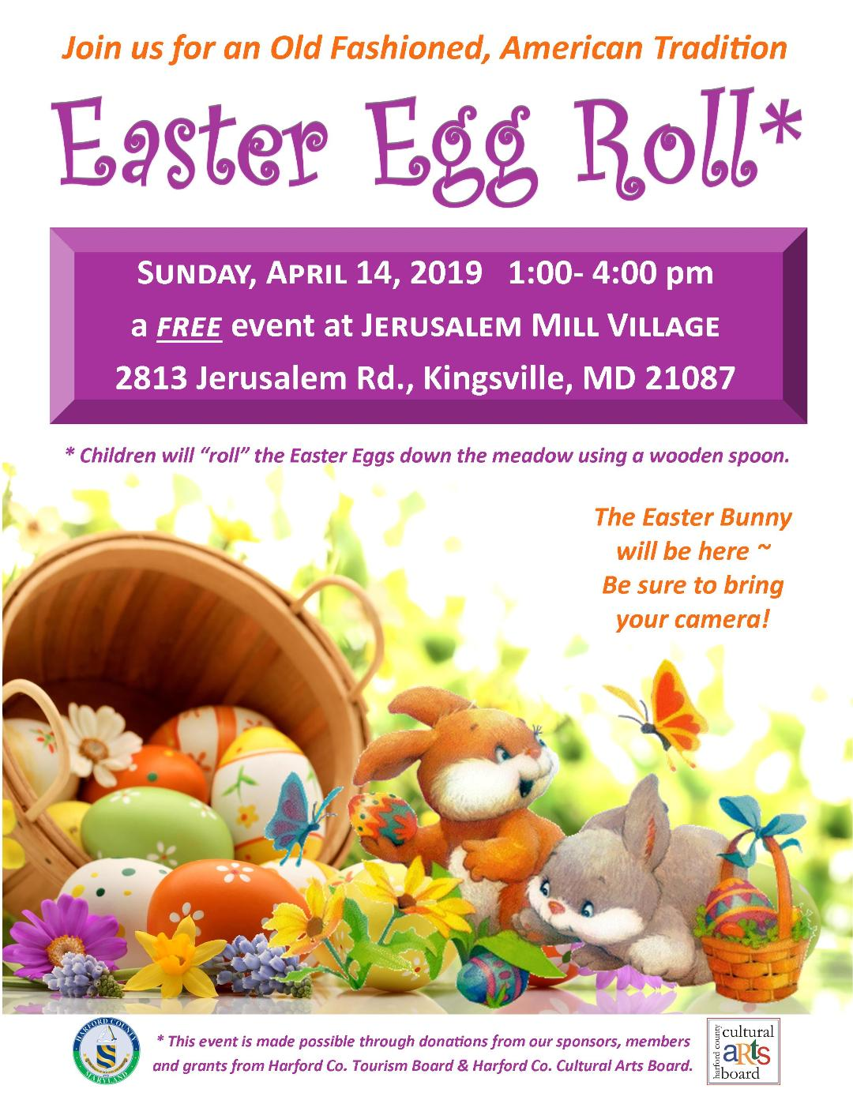

Jerusalem Mill Village Living History Program, 2019

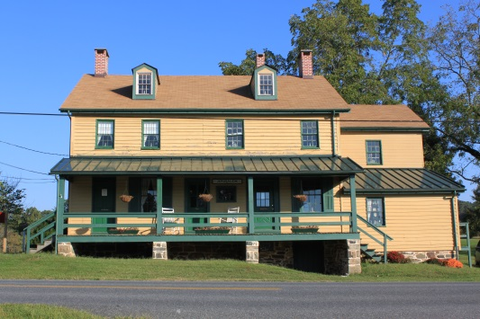

The General Store, Civil War Room and Gift Shop are open on Saturdays and Sundays from 1 p.m. to 4 p.m. Learn about the village’s connection to the Civil War, step into a 1930s general store, and browse our gift shop for a variety of souvenirs including items made by our own blacksmiths.

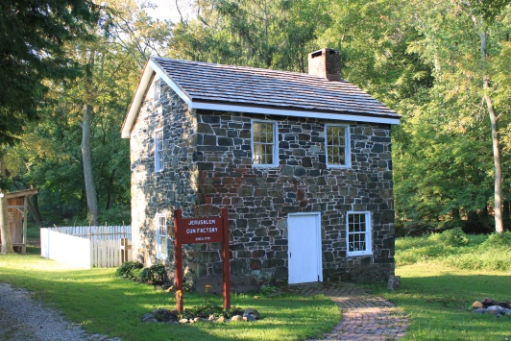

The Miller’s House (a.k.a. “the gun shop”) is open on Sundays from 1 p.m. to 4 p.m. Watch Living History interpreters demonstrate hearth and open fire cooking, gardening, sewing or other activities of daily life in Colonial times.

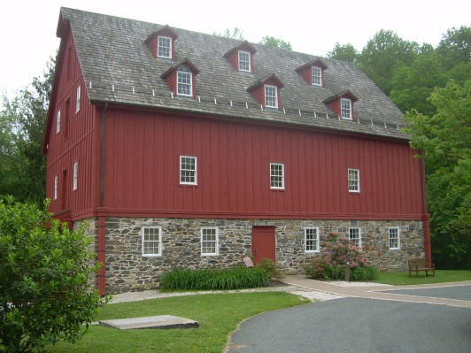

The Grist Mill (Visitor Center and Museum) is open on Saturdays from 10 AM to 1 PM, Sundays and Fridays from 1 PM to 4 PM, and Mondays from 10 a.m. to 4 p.m. Learn about the village, explore our artifacts, and see how a 1772 grist mill operated.

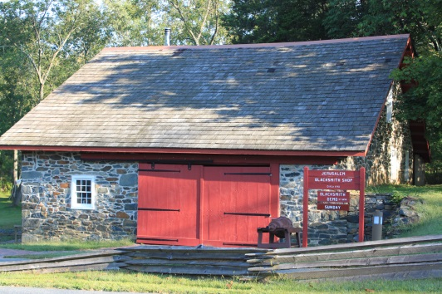

The Blacksmith Shop is open on the second Saturday of every month, from 1 p.m. to 4 p.m. See the forge in operation as our blacksmiths demonstrate their trade.

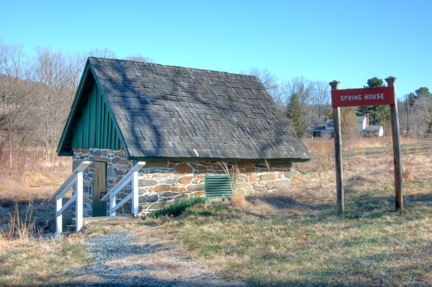

Built over a natural spring, the springhouse was used to store perishable dairy and food items. The spring maintains a year-round temperature of about 56 degrees. The Spring House is open Saturdays and Sundays, 1 PM to 4 PM.

All times listed above are subject to the availability of volunteers.
Thanks to our Sponsors

We are sincerely grateful to our sponsors for their generosity, enthusiasm, and belief in our mission! We encourage all of our visitors to patronize our sponsors’ quality services and products. To inquire about sponsoring our many activities and events, e-mail us at jerusalemmill@yahoo.com !

Welch Mechanical Designs, LLC
Designers and manufacturers of high-quality, high-precision optical systems for commercial, military and scientific applications.
1200 Technology Drive, Suite N
Aberdeen, MD 21001 410-698-3024

HCF&L P.A.
Handwerger, Cardegna, Funkhouser & Lurman, P.A. is a full service tax, accounting, and business consulting firm.
1104 Kenilworth Drive, Suite 300
Towson, MD 21204 410-828-0226

Sunshine Grille - Bistro and Catering
Greek and American cuisine in a casually elegant atmosphere.
12607 Fork Road, Fork, MD 21051
410-592-3378

Wirtz & Daughters Garden Center
Visit us or use our delivery service for mulch, sand, soil, or stone products.
12140 Pulaski Highway, Joppa, MD 21085
410-679-6700 wirtzleahl@gmail.com

Walter G. Coale, Inc.
New Holland tractors, Mahindra tractors, Lawn care equipment, trailers and snow removal equipment for sale
2849 Churchville Rd, Churchville, MD, 21028 410-838-3500

Mr. David Marks
Baltimore County Councilman
P.O. Box 42633
Towson, MD 21284
443-845-5788
davidmarks@verizon.net

It’s All Fun & Games Day Camp
Everything a camp should be!
Located in the Valleybrook Country Club
1810 Valleybrook Drive, Kingsville, MD, 21087 410-879-4460

Harry and Scott Sanders
Long and Foster Realtors
Bringing a heritage of quality to Baltimore and Harford County real estate.
www.come2md.com
Office: 410-515-7400
Scott: 410-977-3675 (c)
Harry: 443-655-0003 (c)

Lassahn Funeral Home
11750 Belair Rd, Kingsville, MD 21087
410-665-2000
hlassahn@lassahnfuneralhomes.com

Bel Air Dental Care
Alan Scharf, DDS and
Gregory Indyke, DDS
2300 Belair Road, Fallston, MD 21047
410-679-6700 or 410-879-8424

Bmore Electric LLC
607 Silverbell Dr.
Edgewood, MD 21040 443-243-8464
Bmoreelectric@gmail.com

Feild Family Dentistry
Gentle Dental for the Whole Family
Dr. Paul E Feild, DDS, PA
12619 Harford Road, Fork, MD 21051
410-592-5420

Yox’s Yard
Small engine and lawn equipment maintenance
12210 Pulaski Hwy., Bldg C
Joppa, MD 21085 410-977-5511
Yoxs.Yard@gmail.com
Gallup Well Services
Well pumps, water treatment, pressure tanks, plumbing
Telephone: 410-321-7244
e-mail: brucehgallup@gmail.com
contact: Randall McGill

Deerfield Electric Co., Inc.
There’s room for your listing here!

Contact us at jerusalemmill@yahoo.com for more information.

Providing professional electrical services for more than 58 years.
7215 Sunshine Ave., Kingsville, MD 21087
www.deerfieldelectricco.com
410-592-7529

Gunpowder Lodge
Unique neighborhood restaurant & bar tucked alongside the Gunpowder River.
10092 Belair Road, Kingsville, MD 21087
410-256-2626

G&M Automotive
Old fashioned service and state of the art equipment.
11825 Belair Rd., Kingsville, MD 21087
https://www.gmautomotive.net/
(410) 592-7111

Alianiello Eye Care
Clinically trained in comprehensive optometry
and the treatment of ocular disease.
11824 Belair Rd., Kingsville, MD 21087
http://alianielloeyecare.com/
410-593-9818

Special thanks to the Harford County Special Grants, Cultural Grants, and Office of Economic Development for their continued support!

Sponsors who (re)registered after April 1st, 2019, will be listed in our Summer and Fall 2019 newsletters, and our Winter and Spring 2020 newsletters.

Source: https://www.charliezahm.com/About.html
Source: https://www.gigmasters.com/classic-rock-band/kaleidoscope
Source: http://www.freerangeblue.com/
Source: http://www.beachbumzband.com/
http://www.greattrainrobbery.com/

