The Gristmill Gazette
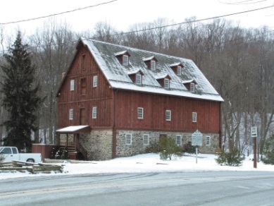
Jerusalem Mill Village
News & Notes
Winter 2019

2811 Jerusalem Rd., Kingsville, MD www.jerusalemmill.org 410-877-3560

Upcoming Events

February 9th – Second Saturday Serve volunteer day, 9 AM until noon. All volunteers are welcome.

March 1st – Opening of the Women’s History display/program/lecture: “Speedbumps on the Way - ‘What If’ Moments on Women’s Road to the Polls”.
7 PM – 9 PM (see newsletter article on page 2 for more information).

March 9th – Second Saturday Serve volunteer day, 9 AM until noon. All volunteers are welcome.

April 13th – Second Saturday Serve volunteer day, 9 AM until noon. All volunteers are welcome.

April 14th – Easter Egg Roll & Easter Bunny Visit, 1 PM – 4 PM. In the event of inclement weather, Easter activities will take place in the Visitor’s Center.

Details on all of our events are available on our web page at www.jerusalemmill.org.
Jerusalem Anniversaries in 2019

- 75 years: Harry Pyle sold the grist mill to Jack Bridges, the last owner to operate the mill.
- 80 years: McCourtney’s store closed permanently.
In the Spotlight:
2018 in Review
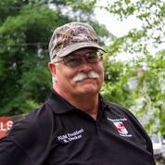

A message from Rick Decker, President, The Friends of Jerusalem Mill

2018 was an incredible year for the Friends of Jerusalem Mill thanks to you, our exceptional volunteers and our wonderful visitors. Here are some of the highlights:

The year started off right when Pat Martin, Paula Johnson, Andrea Staschak & Joan Scovill led and executed an exceptional Spring Dinner, at which we honored Chris and Joan Scovill for a lifetime of service and dedication.

We added a new event this year. We sponsored “Amy Caprio’s Memorial Ride”, which started at the Historic Jerusalem Mill Village. Officer Caprio lost her life in the line of duty responding to a call in a Perry Hall Neighborhood on the afternoon of Monday, May 21st, 2018. The response to this event was overwhelming. Over three hundred riders and walkers participated. All proceeds were donated to the Harford Humane Society and the Baltimore County Police Assistance and Relief Fund in Amy’s name. Our intentions are to integrate this ride into our 1st Responder’s Day event this year.
Our fourth annual 1st Responder’s Day was an outstanding success. Kingsville Volunteer Fire Department won the annual “Smack Down” and has bragging rights and trophy for the next year.

Significant volunteer efforts have included fifteen volunteer workdays conducting routine maintenance around the village; preparation and oversight of six Conservation Job Corp projects within Gunpowder Falls State Park, including an outline of the sawmill and interpretive panel, removal of invasive plants, trail repairs, etc.; six Eagle Scout Service Projects and three Girl Scout Silver or Gold Award projects.

Again we thank the Maryland Questers for their large donation that enabled us to restore the double door to the McCourtney’s General Store.

Special thanks to a large anonymous donation, we have been able to add additional equipment to our inventory that will expand our maintenance capability.

Our events were outstanding. The Summer Concert Series was successful and the Beach Bumz were a great finish. The Easter Egg Roll in April, Gilmor’s Raid interpretation in July, and the Christmas in the Village in December were well appreciated by our visitors. Other activities, like our two yard sales and annual Gunpowder Invitational and 50K Cross Country Races, were very successful and provided sizable donations.

Although it was a record-setting year for precipitation in our area, it didn’t stop visitors from enjoying all that the village has to offer. In 2018 we had visitors from 40 states, plus the District of Columbia. We also had visitors from 11 other countries and territories, the most foreign visitors in any year on record.

Administratively, our By-Laws and Volunteer Handbook were updated and approved by the officers, Board of Directors and members, with the help of the senior park staff. Both documents can be reviewed at https://jerusalemmill.org/volunteer/.

2019 has come with new opportunities and challenges. Our First Day Hike had over 295 participants and was an exceptional success. Nita Settina, Superintendent of Maryland Park Service, sent a personal note to us: “Thanks, Rick! It was a record breaking day of First Day Hikers to kick off 2019 in the State Parks. Looking forward to working together in the coming year. Thanks as always for your support. We really appreciate it!”

Our current lease will be expanded to include the entire village. The expanded responsibilities will require additional volunteers and more fund-raising efforts. Senator JB Jennings and Delegate Kathy Szeliga have jointly sponsored a bond-bill in the Maryland legislature to raise $250K to address some of these requirements. One significant project that we are looking forward to completing is the restoration of the miller’s house windows this spring. We are also hoping to raise funds to continue the bank barn reconstruction.

Thanks again to all who made this a successful year for the members of the Friends of Jerusalem Mill, the Maryland Park Service, Department of Natural Resources and our visitors.
Women’s History Program

Women's History Month, established by Congress in 1987, is an annual celebration that focuses on the contributions of women to events in history and contemporary society. Jerusalem Mill will participate in the celebration with a new display that will be introduced on March 1st, in the Jerusalem Mill Visitor Center – Museum, 2813 Jerusalem Rd., Kingsville, MD. The highlight of the opening of the new display will be a guest lecture by Dawn Fairchild. The lecture is titled “Speedbumps Along the Way: ‘What-If’ Moments on Women’s Road to the Polls.” Ms. Fairchild has served local, state, national and international groups as speaker, educator, professional parliamentarian, bylaws consultant, and meeting facilitator. She is a recognized resource in the field of historic garment reproduction. Sewing since the age of 4, under the early tutelage of her great-grandmother and with an appreciation of American history fostered by her parents, she combines these lifelong interests to reproduce historic garments and share her research and insights about the eras in which they were worn. Her work has been displayed in museums and historic sites in New Jersey, Mississippi and Washington, D.C. She has developed this lecture to complement the inaugural Women’s History exhibit at Jerusalem Mill Village.

Because of the limited space, seating will be limited the first 30 people to pre-register. To pre-register for this event, please send an e-mail to jerusalem.mill.curator@gmail.com, with the word “Register” in the subject line and list the name(s) of attendees in the body of the e-mail with e-mail addresses and phone number(s). If you want to register but don’t have access to e-mail, call the Visitor Center at 410-877-3560 and leave a message indicating that you want to register, and provide the name(s) of attendees and phone number(s). You will receive a response indicating whether you are registered or on the waiting list.
Meet Our Volunteers

Each quarter we’ll introduce you to one of our volunteers. As a non-profit charitable organization, with no paid staff, we greatly appreciate our dedicated volunteers. We want to share their stories with you.

Laura Franks will be serving as a docent in the Visitor Center – Museum from 1 to 4 on the first and fourth Saturday of each month. Laura has lived in the White Marsh/Perry Hall for more than 40 years, and has worked in the Information Technology field for 25 years. She has also volunteered for the Maryland Food Bank, Habitat for Humanity, and Clean Up events at Fort McHenry and Point Lookout State Park, and has participated in Civil War Living Histories for about 7 years. Laura also helps out in the village’s miller’s house.

Mark McDonald also lives in Perry Hall and has visited and taken part in various Jerusalem Mill celebrations and activities over the years. As a former middle school teacher, he has brought his U.S. History students to the village. His teaching assignments included Carroll County and Baltimore County Public Schools, and Loyola University of Maryland. His other volunteer activities have included The University of Maryland as a master gardener, the Gunpowder Valley Conservancy and St. Paul’s Lutheran Church in Kingsville. Mark will serve as a docent in our Visitor Center – Museum every Monday from 1 to 4.

Please stop in to meet our new volunteers.
Summer Concert Series

The 2019 schedule for Jerusalem Mill’s concerts in the meadow has been set:

June 9th – Charlie Zahm – Celtic and 18th and 19th century North American music.

June 23rd – Kaleidoscope – A wide range of R&B, classic rock, country and top 40 songs.

July 7th – Free Range Blue – Acoustic Americana band playing folk, bluegrass, country, Celtic, jazz, blues and much more.

July 21st – Beach Bumz – Beach music from Jimmy Buffet, the Beach Boys and other summer music classics.

August 4th – Great Train Robbery – “Classic smokey southern sound”, playing classic rock.
Farewell to John Peeler

As sorry as we are to see John Peeler leave Jerusalem Mill Village’s Living History program, we’re happy for him and proud that the quality of his work has been recognized by Colonial Williamsburg. Williamsburg has offered John a paid apprenticeship program and follow-on employment. John has been our master woodworker/joiner since last year, and has made significant improvements to the joinery/woodworking shop. He also introduced the village to the National Federation for the Blind, by organizing an education day for blind students from all over the country. We wish John all the best and thank him for his contributions to the Friends of Jerusalem Mill.
In Memoriam

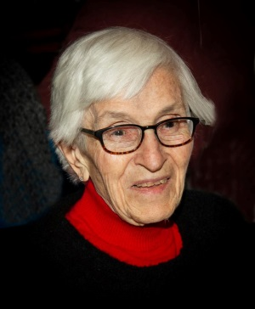

Dr. Phyllis Pullen:
February 10, 1923
- October 22, 2018

It is with great sadness that we bid farewell to Dr. Phyllis Pullen, the last resident of the former Lee Mansion located in Jerusalem Mill Village. Dr. Pullen and her husband, Keats A. Pullen, Jr., moved into the 25-room mansion in 1954. Ten years and three children later she became a doctor! As Dr. Pullen explained to our editor, she had stayed busy raising Norwich terriers and Shetland ponies on the property, and dabbled in art, but “was bored” and decided to become a doctor. After being rejected by Johns Hopkins because they felt it would be too difficult for a woman with three children, she applied to, and was accepted by, the University of Maryland School of Medicine. She was one of only two women in the class, and graduated magna cum laude, completing her internship and residency at the University of Maryland Medical Center. Dr. Pullen was 35 when she attained her medical degree!

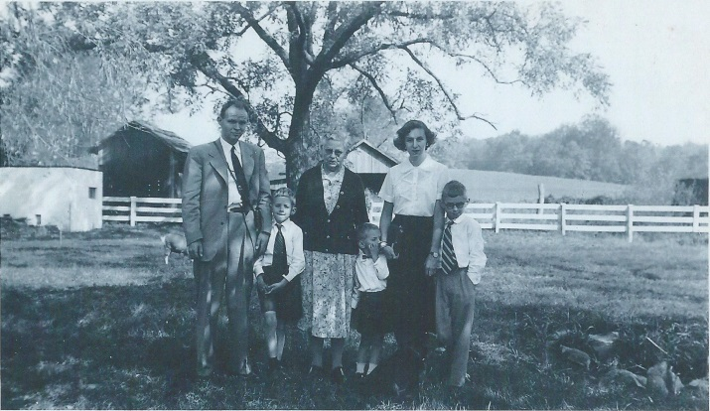
Pullen family in 1954

Dr. Pullen established her practice in their home in Jerusalem Mill Village, and considered herself one of the last country doctors, even making house calls, often in jeans. She worked until the age of 85, retiring in 2008, but kept her license active until she passed away last October at the age of 95. Dr. Pullen was a major supporter of the Friends of Jerusalem Mill and made significant contributions to the village over the years. We will miss her greatly.
To contact the newsletter editor, send an e-mail to jerusalem.mill.curator@gmail.com, or call the Visitor Center – Museum at 410-877-3560.
Jerusalem Mill Village Living History Program, 2019

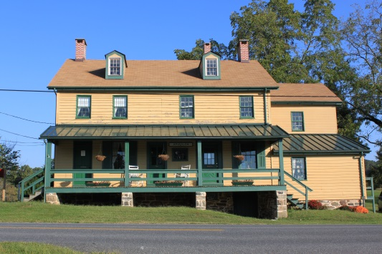

The General Store, Civil War Room and Gift Shop are open on Saturdays and Sundays from 1 p.m. to 4 p.m. Learn about the village’s connection to the Civil War, step into a 1930s general store, and browse our gift shop for a variety of souvenirs including items made by our own blacksmiths.

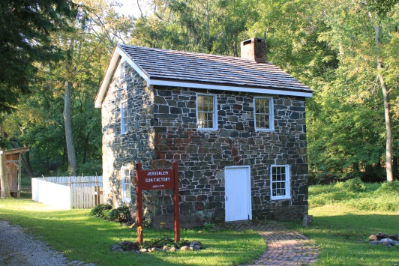

The Miller’s House (sometimes called “the gun shop”) is open on Sundays from 1 p.m. to 4 p.m. Watch living history interpreters demonstrate hearth and open fire cooking, gardening, sewing or other activities of daily life in Colonial times.

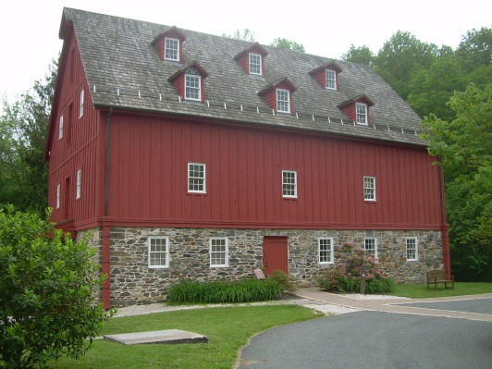

The Grist Mill (Visitor Center and Museum) is open on Saturday through Monday from 10 a.m. to 4 p.m., and Fridays from 1 p.m. to 4 p.m. Learn about the village, explore our artifacts, and see how a 1772 grist mill operated.

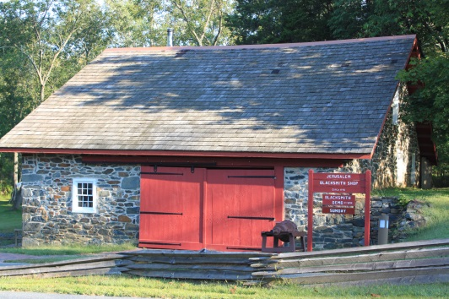

The Blacksmith Shop is open on the second Saturday of every month, from 1 p.m. to 4 p.m. See the forge in operation as our blacksmiths demonstrate their trade.

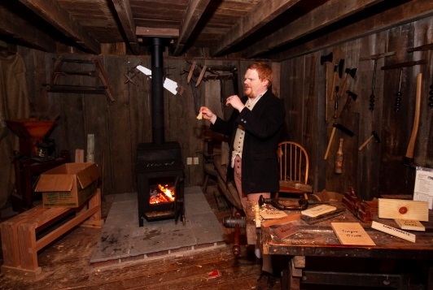
The Joinery, located in the front room of the Carriage House, adjacent to the mill, is where our colonial woodworker demonstrates the tools and techniques used in colonial times. It is temporarily closed until we can find a volunteer woodworker.

We are sincerely grateful to our sponsors for their generosity, enthusiasm, and belief in our mission! We encourage all of our visitors to patronize our sponsors’ quality services and products. To inquire about sponsoring our many activities and events, e-mail us at jerusalemmill@yahoo.com !

Welch Mechanical Designs, LLC
Designers and manufacturers of high-quality, high-precision optical systems for commercial, military and scientific applications.
1200 Technology Drive, Suite N
Aberdeen, MD 21001 410-698-3024

HCF&L P.A.
Handwerger, Cardegna, Funkhouser & Lurman, P.A. is a full service tax, accounting, and business consulting firm.
1104 Kenilworth Drive, Suite 300
Towson, MD 21204 410-828-0226

Sunshine Grille Bistro and Catering
Greek and American cuisine in a casually elegant atmosphere.
12607 Fork Road, Fork, MD 21051
410-592-3378

Wirtz & Daughters Garden Center
Visit us or use our delivery service for mulch, sand, soil, or stone products.
12140 Pulaski Highway, Joppa, MD 21085
410-679-6700 wirtzleahl@gmail.com

Walter G. Coale, Inc.
New Holland tractors, Mahindra tractors, Lawn care equipment, trailers and snow removal equipment for sale
2849 Churchville Rd, Churchville, MD, 21028 410-838-3500

TSW Roofing Solutions
1615 Robin Circle, Suite G
Forest Hill, MD 21050 410-979-7876

Joppatowne Garden Club
Perry Hall, MD 21128 410-698-5786

Friends of David Marks
Baltimore County Councilman
councilmanmarkscampaign@gmail.com

Amateur Jousting Club of Maryland
e-mail: phoffman12@verizon.net

Lassahn Funeral Home
7401 Belair Rd, Baltimore, MD 21236
410-665-2000
hlassahn@lassahnfuneralhomes.com

Bel Air Dental Care
Alan Scharf, DDS and
Gregory Indyke, DDS
2300 Belair Road, Fallston, MD 21047
410-679-6700 or 410-879-8424

Corbin Fuel
Blue Ribbon pricing and service!
33 East Ellendale Street
Bel Air, MD 21014-0689
410-879-0579, 410-838-3590, or
1-800-474-3590

Reds Wine and Spirits
Catering, Deli, Prepared Foods, Butcher – Fresh Cut Meats, Wine, Beer, Liquor, Groceries, ATM, Lottery, Propane
12037 Belair Road, Kingsville, MD 21087
410-592-6202

It’s All Fun & Games Day Camp
Everything a camp should be!
Located in the Valleybrook Country Club
1810 Valleybrook Drive, Kingsville, MD, 21087 410-879-4460

Party Party
Your total party headquarters!
222 Commerce Road, Forest Hill, MD, 21050 410-893-3321

Gunpowder Lodge
Unique neighborhood restaurant & bar tucked alongside the Gunpowder River.
10092 Belair Road, Kingsville, MD 21087
410-256-2626

Bmore Electric LLC
Edgewood, MD 443-243-8464
Electricalcontractoredgewood.com

Feild Family Dentistry
Gentle Dental for the Whole Family
Dr. Paul E Feild, DDS, PA
12619 Harford Road, Fork, MD 21051

Pete’s Pickins Antiques and Collectables
Over 40 years of experience buying and selling quality antiques!
7901 Bradshaw Road,
Upper Falls, MD, 21156
410-592-6884 or 410-592-5420

Prosperity Home Mortgage, LLC
Put Prosperity in your life!
Joseph H. Bragg, III, Home Mortgage Consultant (NMLSR #209891)
3004 Emmorton Road, Abingdon, MD, 21009 410-515-6007

Harry and Scott Sanders
Long and Foster Realtors
Bringing a heritage of quality to Baltimore and Harford County real estate.
12514 Jerusalem Road, Kingsville, MD, 21087 410-592-6751

Maryland Army National Guard Recruiting and Retention
NCO SGT Kimberly Kerschner
4244 Montgomery Rd
Ellicott City, MD 21043
443-789-9269
Kimberly.D.Kerschner.mil@mail.mil

The Flanders Group
Wealth Management, CPA,
and Tax Service
221 Maitland Street, Bel Air 21014
Telephone: 410-569-4506
Email: info@flanderscpa.com

Yox’s Yard
Small engine and lawn equipment maintenance
12210 Pulaski Hwy., Bldg C
Joppa, MD 21085 410-977-5511
Yoxs.Yard@gmail.com
Dunk’n Donuts
1920 Belair Rd., Fallston, MD
410-877-2445

Gallup Well Services
Well pumps, water treatment, pressure tanks, plumbing
Telephone: 410-321-7244
e-mail: brucehgallup@gmail.com
contact: Randall McGill

Cherokee Raiders
Non-profit organization; Western and English equestrian show series.
608 N. Tollgate Rd., Bel Air, MD
cherokeeraiders@gmail.com

K.P. Hubers Produce Farms
7110 Mt. Vista Rd., Kingsvill, MD
410-593-9670

Chesapeake Nine of Baltimore
Vintage Baseball Team (19th century)
Contact: jtstanik@att.net
www.Mavbbl.com/capitol-conference/chesapeake-nine-of-baltimore/

Deerfield Electric Co., Inc.
Providing professional electrical services for more than 58 years.
7215 Sunshine Ave., Kingsville, MD 21087
www.deerfieldelectricco.com
410-592-7529

This newsletter is also supported by a grant from the Maryland State Arts Council and the Harford County Cultural Arts Board.

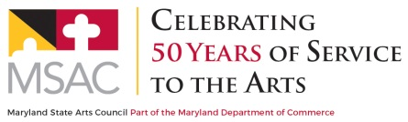
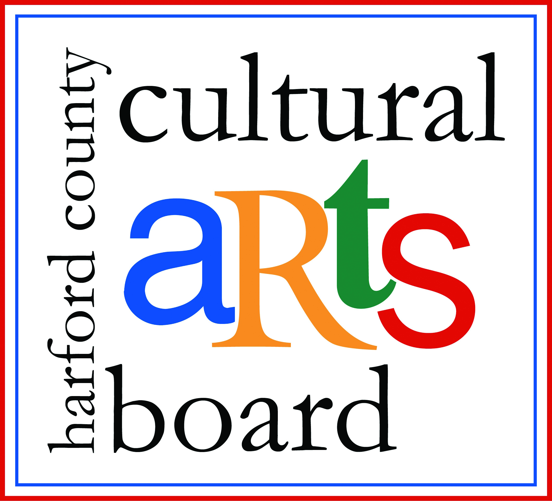

Special thanks to the Harford County Special Grants, Cultural Grants, and Office of Economic Development for their continued support!

