The Gristmill Gazette
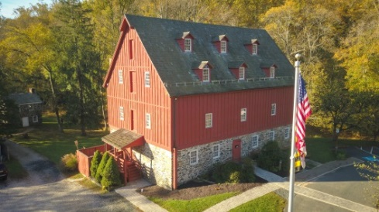
Jerusalem Mill Village
News & Notes
Summer 2019

2811 Jerusalem Rd., Kingsville, MD www.jerusalemmill.org 410-877-3560

Upcoming Events

All activities are in the village, unless otherwise indicated.

July 7th – Elkton Eclipse vs. Chesapeake Nine (vintage baseball). Admission is free.

July 7th – Free Range Blue concert by the Little Gunpowder Falls. Acoustic Americana band playing folk, bluegrass, classic country, Celtic, jazz, blues and much more. 6 PM – 8 PM. See page 7 for more information.

July 13th – Second Saturday Serve volunteer day, 9 AM until noon. Come help us with tasks throughout the village.

July 20th – Jerusalem Mill Tournament Joust – 11 AM.

July 21st – Beach Bumz concert by the Little Gunpowder Falls. Beach music from Jimmy Buffet, the Beach Boys and other summer music classics. 6 PM. – 8 PM. See page 7 for more information.

August 3rd – First Responder’s Day with Smack-down contest with teams from the Kingsville Volunteer Fire Company, Joppa Magnolia Volunteer Fire Company, and the Department of Natural Resources. Exhibits and activities are available for all ages.

August 4th – Great Train Robbery concert by the Little Gunpowder Falls. Classic smokey southern sound playing classic rock. 6 PM – 8 PM. See page 7 for more information.

August 10th - Second Saturday Serve volunteer day, 9 AM until noon. Come help us with tasks throughout the village.

September 14th – Amateur Jousting Club Championship Joust – 11 AM.

September 14th - Second Saturday Serve volunteer day, 9 AM until noon. Come help us with tasks throughout the village.

Details on all of our events are available on our web page at www.jerusalemmill.org.

In the Spotlight:

We have added a lot of new subscribers since the Spring edition of this newsletter, so this is a good time to (re)introduce the Jerusalem Mill Village and the Friends of Jerusalem Mill.

The Village

Established in the 1770s, Jerusalem Mill Village is a nearly intact mill village located in Kingsville, Maryland. It has been listed on the National Register of Historic Places since 1987. The centerpiece of the village was the grist or grain mill (pictured in the newsletter header), dating to 1772 - prior to the American Revolution. One of numerous mills in this area, it was distinguished from other mills by its technology and its longevity. Unlike typical mills that have one external water wheel, this mill had two wheels, and they were in the basement. The advantage of this arrangement was to address the vulnerability of external wheels to freezing up in the winter. The grist mill produced flour and corn meal, and remained in operation until 196, just short of 200 years! The mill sat vacant for 14 years, during which time the weather and vandalism took its toll, until it was restored under a partnership of the Department of Natural Resources and the non-profit Friends of Jerusalem Mill. Today the mill serves as a Visitor Center – Museum, and the headquarters of the Gunpowder Falls State Park. The Visitor Center – Museum is open to the public most Saturdays, Sundays and Mondays.

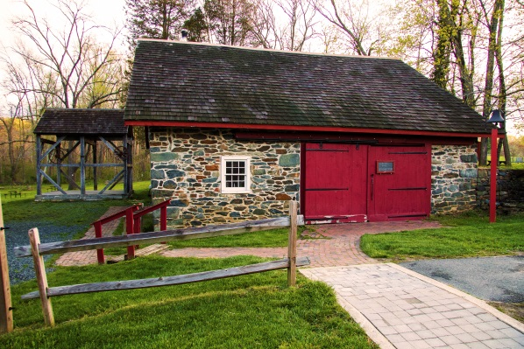
Immediately adjacent to the grist mill was a sawmill that had its own water wheel and shared the head race with the grist mill. Across the road from the mill is the blacksmith shop (c. 1800), and adjacent to it, now represented in “ghost frame” format, was the wheelwright shop. Though of great utility to the greater community, the priority for these two craftsmen was to fabricate parts and make repairs to the mills. Today the blacksmith shop is part of the village living history program, where blacksmiths demonstrate the trade on weekends and special occasions. The wheelwright frame is a popular stop for professional and amateur photographs (and serves as a bandstand during summer concerts).

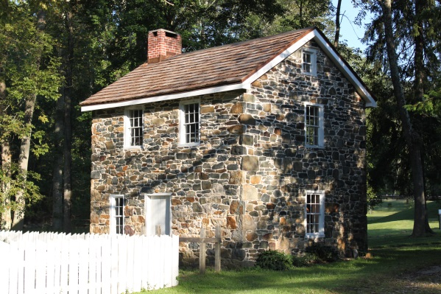
Behind the mill is a small stone building (c. 1770) that once was a cooperage where barrels were made to store and ship the flour manufactured in the mill. It has also been known to serve as a “Gun Shop”, since they allegedly made black walnut gunstocks for muskets used by the Maryland Militia during the American Revolution. During much of its history this small building served as the miller’s house, and at one time provided a home for a family of seven. The miller’s house is also part of the living history program, and one can often witness open-hearth cooking on Sunday afternoons.

Another popular building in the village is the former general store and post office, which is located at the intersection of Jerusalem Road and Jericho Road. The general store, typically referred to as McCourtney’s Store, was probably built between 1830 and 1837, and had its moment during the Civil War when a Confederate Cavalry unit raided the store in July of 1864. Today the store houses a Civil War room, a 1930s general store, McCourtney family artifacts and the Jerusalem Mill Gift Shop. McCourtney’s Store is open on weekends and special occasions.

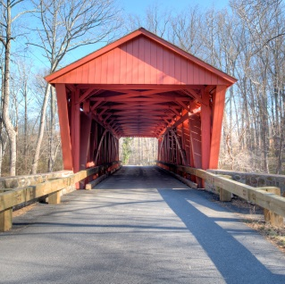
The general store faces in the direction of the Jericho Covered Bridge. Built in 1865, it is one of only three “working” covered bridges remaining in Maryland. Other buildings in the village include a tenant house (across the street from the general store) where a farmer typically lived and who was responsible for the livestock and contents of the large bank barn (meaning built into an embankment) which is located between the tenant house and the covered bridge. Built around 1803, the Bank Barn was destroyed by arson in 1961, and is currently being restored.

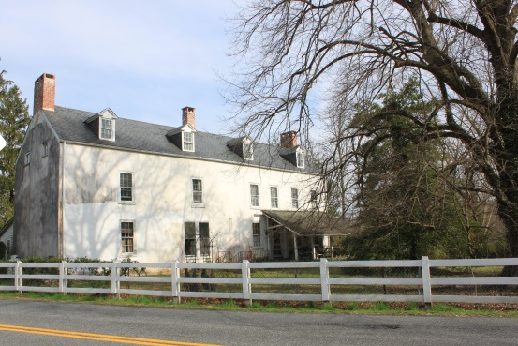
Another prominent structure in the village is the Lee Mansion, probably built in the era of the Civil War. As the founding family of the village, the Lee family built a residence befitting their status – a 2 ½ story, slate-roofed, 20-room mansion. In the 1960s the mansion became the home of Dr. Phyllis Pullen, one of the early female doctors in Maryland and one of the last “country doctors”, with her practice in the mansion. The mansion was a private residence until late 2018, and plans are being developed to include it in the living history program.

The village has two stone spring houses, each of which maintain a year-round temperature of 56 degrees, and were used to store perishable dairy and food items. The spring house next to the Lee Mansion is a two-story structure with a spring house on the lower level and smoke house on the upper level, the latter used for curing meats. The smaller spring house, to the north of McCourtney’s Store is open on weekends.

The Organization

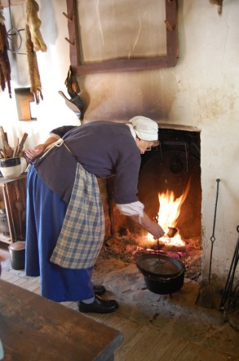
The entire village is maintained and operated by the Friends of Jerusalem Mill (FOJM), an all-volunteer organization formed in 1985 to preserve the rich history of the Jerusalem Mill Village and to provide an educational and entertaining experience for our visitors. Our volunteers devote significant energy to keeping alive the heritage and traditions that form our common bonds and our deepest roots. Historic reenactments and an active year-round living history program offer visitors countless chances to witness the history of the 18th and 19th centuries and to honor Americans' early struggles for freedom and prosperity. Each year over 800,000 visitors enjoy watching our history interpreters and reenactors demonstrate blacksmithing, open hearth cooking, colonial gardening, storekeeping, and other crafts.

The Friends of Jerusalem Mill is a 501(c)(3) non-profit organization dedicated to preserving, protecting, restoring, researching, collecting, interpreting and providing educational opportunities on Jerusalem Mill Village's historical, cultural, environmental, and natural resources. As such, individuals and businesses may be able to take advantage of tax deductions for their generous donations.

Activities

Since the village is located in the Gunpowder Falls State Park, there are picnic tables and hiking trails available for use every day. The village grounds and the park trails are open from sunrise to sunset. On weekends the village comes alive with living history demonstrations, when some of the historic buildings are also open to the public. Throughout the year the village is host to a variety of activities such as jousting tournaments, vintage baseball (1860s rules, equipment and uniforms), concerts by the falls, Easter Egg Roll, Christmas in the Village, Halloween activities, cross country meets, field trips for school children, First Responder’s Day, Village Yard Sales, weddings, birthday parties, and more. Information on all of the public events can be found on our web site at www.jerusalemmill.org, or by calling the Visitor Center on 410-877-3560. To schedule your private event, call us on 410-877-3679.

National Federation of the Blind Visits Jerusalem Mill Village
by Mark McDonald

On June 28th Jerusalem Mill Village hosted 29 students, faculty and interns from the National Federation of the Blind (NFB). The students traveled to Maryland from all over the United States; Washington, Utah, Vermont, New Hampshire, Georgia, and Alabama to name a few. As stated by Natalie Shaheen, the NFB Science Project Director, the purpose of the visit was to enable the students to study the structural skeleton of buildings at a historical site. At week’s end scale models of buildings were to be built by the students using balsa wood and glue. Natalie shared that last year after visiting the village several students employed techniques and designs they had experienced here.

Gail and Kit Wattenbarger and Mark McDonald acted as facilitators for the visit. A hike through the woodlands to the Jericho Covered Bridge and bank barn was led by Gail. Students commented to her about the number of trees along the walk. They asked what kinds of trees and flora there were. Interest rose at the barn site, with questions about the building and use of the bank barn. As cars rumbled over the Jericho Covered Bridge and the sound of rushing water was heard, excitement came over the students. A 15-inch bolt and washer from the old and new bridge were passed around and examined.

Kit was stationed in the joinery/woodshop and the miller’s house/musket shop. While in the shop students were able to touch some of the joiner’s tools and study samples of various joining techniques: tongue and grove, dove tailing, etc.

A brief history of the mill and village was given by Mark. The discussion began by asking what a grist mill was. Only one student knew the answer, so to clarify, stalks of wheat and a sack of baking flour was passed around. Afterwards they felt the groves in the mill stone and passed around the miller’s hammer used for sharpening the stones grooves. They then proceeded to examine the buckets and belts used to lift the grindings to the floor above. They also briefly discussed the phrases “nose to the grind stone” and “run of the mill”. When finished they had a rudimentary understanding of the milling process and how water power was harnessed.

To help them with their project of building a model they examined the beams, columns, joist, and the second floor boards from a step ladder in the mill. Climbing up the ladder enabled them to feel the axe and saw marks on the wood and fitting of the mill and wheel wright shop. This inspection of the skeleton of the buildings would prove useful to them when doing their science project.

When they visited the blacksmith’s shop they handled a few of the hammers and tongs and metal pieces the blacksmith made for village use. The weight of the hammers particularly impressed them.

The day was filled with inquiry and enthusiasm from the students and their teachers. Even a found walnut sparked interest and discussion. It was fascinating to watch four of the students interact with their guide dogs. This was a very rewarding experience for the students, teachers, interns and the host Friends of Jerusalem Mill.

155-Year Anniversary

This year we celebrate the 155th anniversary of the Confederate Cavalry unit raid on the General Store in Jerusalem Mills. Here’s how the raid was covered in the 1864 edition of Baltimore’s newspaper, The Sun: “Yesterday was a day of great excitement in a portion of Harford county [sic]. At an early hour of the morning a squad of rebel cavalry appeared at Jerusalem Mills, and made a requisition on Mr. David Lee for horses and such articles as they needed from the store, including boots and shoes and other wearing apparel. Mr. Lee estimates his loss, including horses, and flour destroyed by the burning of the warehouse at Magnolia, at about $1,000. The raiders spared the mill and other buildings…After leaving Jerusalem Mills they proceeded to Magnolia, arriving just in time to capture the 8 40 A.M. train from Baltimore.” The unit then waited and also captured the 9:50 a.m. Express. One of the passengers on the trains was Major General Franklin of the Union Army, who was taken prisoner. After removing all passengers, the trains were set on fire and one was pushed onto the bridge over the Gunpowder to destroy the railroad bridge.

Be sure to visit our General Store and enjoy the informative displays and artifacts in our Civil War room.

The Mill Model Returns!

For the past six weeks our scale model of the 1772 grist mill has been on display in the Almshouse at the Historical Society of Baltimore County (HSBC), as part of a traveling exhibition from the Smithsonian’s Museum on Main Street (MoMS) program, called “Water/Ways”. The Water/Ways exhibit examines the crucial role of water in our lives: water as an essential biological and natural resource; sources of water; water as a connector and border; harnessing water’s power; water as a finite resource; and our relationship with water. The mill model is a great example of harnessing water’s power, in this case to facilitate the commercial production of flour and corn meal. Designed and built by Brian Payne, and funded by the Society of Colonial Wars and the Friends of Jerusalem Mill, our model shows how the water wheels provided the power needed to turn four sets of grindstones to grind wheat into flour and corn kernels into corn meal. Brian spent countless hours adding more details to the model in preparation for this exhibit, and the Friends of Jerusalem Mill updated the display case. If you missed the exhibit at HSBC, you’ll soon be able to see the improved model back in its home in the grist mill at Jerusalem Mill.

To learn more about the exhibit, and see a picture of our model on the front page of the “Bay Journal” visit https://www.bayjournal.com/article/water_ways_exhibit_brings_impact_of_local_rivers_to_light .

Here’s a piece of trivia about the mill: Although it is located in Kingsville, just east of the Little Gunpowder Falls, in Harford County, it was actually built in Baltimore County! When the mill first opened for business in 1772, Harford County didn’t exist, because it wasn’t established until 1774 when this portion of Baltimore County became part of the new Harford County.

Meet Our Volunteers

Each quarter we’ll introduce you to one of our volunteers. As a non-profit charitable organization, with no paid staff, we greatly appreciate our dedicated volunteers. We want to share their stories with you.

Mary Ellen Haisfield-Wolfe joins the mill docent staff this month. She has a PhD in nursing from the University of Maryland and also has experience as a clinical data manager. Her other volunteer work includes hospitality at her church, and Mentoring Male Teens in the Hood (their goal here is to save young lives from falling prey to all of the evil forces that exist in many of our neighborhoods). Mary Ellen has a wide variety of interests, to include hiking, bicycle riding, visiting historical places, reading and Mahjong. She also loves history and historical preservation, which is a perfect fit for Jerusalem Mill Village! You’ll find Mary Ellen in the Visitor Center – Museum on the fourth Monday of every month, from 10 AM to 1 PM. Please join us in welcoming Mary Ellen to the team.

We’re also pleased to introduce our college intern for the Fall semester: Brandon Kelly. Brandon comes to us from the Harford Community College, and he will be working in the Visitor Center – Museum gaining experience in historical research, curatorial work, serving as a docent, conducting oral histories, designing exhibits, artifact preservation, and writing. He is particularly interested in the civil war era. Brandon has experience volunteering at the Child Safety Fair at Shamrock Park and at the Bel Air Police Department youth camp. Brandon is a Corporal in the Bel Air Police Explorer Post 9010. His interests include civil war reenacting, metal detecting, visiting museums, boating, crabbing, and kayaking. We look forward to working with Brandon.

In Memorium

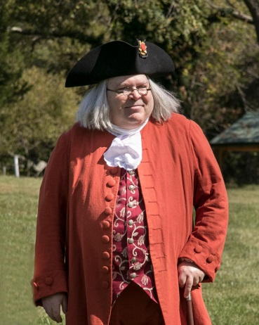
Dave Fisher of Fallston, Maryland passed away this past April 10th. Born on February 21, 1953 in Fort Ord, CA, Dave was a retired salesman, avid history enthusiast, amateur actor, and a member of Salem United Methodist Church on Bradshaw Rd., not far from Jerusalem Mill. During his years in retirement Dave spent much of his time studying the life of Ben Franklin and took great pride in his historical re-enactment of Mr. Franklin, which he did during some of our living history events and on numerous occasions over the past several years for the many school groups hosted by the Friends of Jerusalem Mill on “Education Days”. Dave portrayed the appearance, speech and mannerisms so accurately that students and other visitors experienced what it would be like to actually talk to Mr. Franklin. Dave will surely be missed.
Photo by Jack Benesch

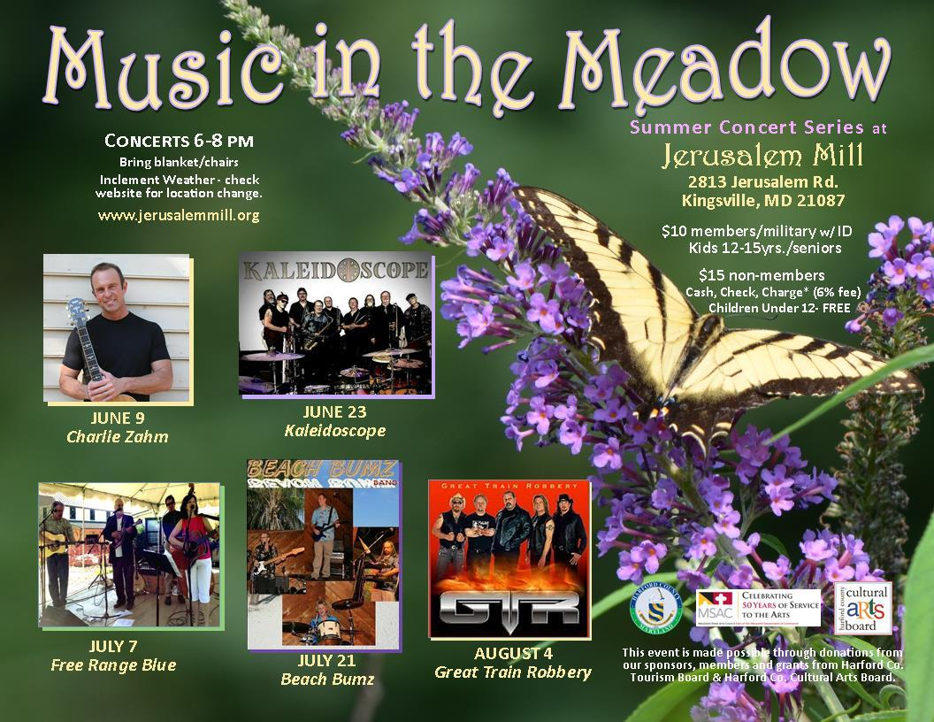

We Need Your Help

Because The Friends of Jerusalem Mill is a non-profit charitable organization, we rely on generous donations of time and money from our many volunteers and donors to accomplish our mission of preserving and presenting local history. Let us know if you have some time to spare and can help us continue our mission. Here’s just a sample of some of the volunteer opportunities:

Docents: Greet visitors and guide them through the visitor center/museum, the general store, or the Civil War Room. Provide information about the history and operation of the village and answer questions about the park. No prior knowledge of the village history or details about the park is required. Our Volunteer Handbook has all of the information you’ll need.

Special events: Plan and organize. Collect tickets/admission, set up chairs, tables, canopies, etc., direct parking, assist pedestrian crossings, guide visitors, tear-down, etc. This can be a year-round commitment or a one-event commitment.

Research/Curatorial Assistants: Identify and inventory artifacts; perform various research projects online, at historical societies and archives; create displays, etc. Focus areas include genealogy, architecture, archeology, history and sociology.

Living History Interpreters: Wear era-appropriate attire, share knowledge of various aspects of life in the 18th and 19th century. Most immediate need is for a carpenter/woodworker, toy demonstrator, cooper, tinsmith, gardeners/farmers, colonial cooks, tour guides.

Grant writers: Help us manage our grant program by preparing grant applications for a wide variety of projects and purchases. Maintain a calendar of deadlines to ensure we don’t miss an opportunity or obligation. This function can mostly be performed at home or office!

Village Maintenance and Repairs: Second Saturday Serve is a year-round, monthly event open to volunteers of all ages, on the second Saturday of every month, from 9:00 a.m. until noon, to perform a wide variety of tasks. Just show up and we’ll put you to work!

Lawn maintenance is performed every Wednesday during the growing season, any time between 8:30 and 12:30. It includes walk-behind or riding mowing, and weed-wacking. We have a lot of property to maintain, and that takes a lot of volunteers!

Trail maintenance: Hike the wooded trails of the Gunpowder Falls State Park Central Area and pick up trash, remove debris from the trails, refresh blazes on the trees, trim back overgrowth, and report downed trees and other hazards to the park office.

Donations:

Financial contributions can be made through membership, business sponsorship, renovation or maintenance fund contributions (cash or check), or by selecting the Friends of Jerusalem Mill as the charity of choice when you purchase through AmazonSmile (smile.amazon.com).

You can also donate household goods, tools, gently used furniture, toys, etc. to be sold in our semi-annual yard sale. Yard Sale items are accepted year-round. Just call the Visitor Center on 410-877-3560 to arrange for drop-off.

You can get more information on all of these opportunities at www.jerusalemmill.org, or e-mail us at jerusalemmill@yahoo.com, or call us on 410-877-3560.

To contact the newsletter editor, send an e-mail to jerusalem.mill.curator@gmail.com, or call the Visitor Center – Museum at 410-877-3560. To add another e-mail address to our subscription list, simply reply to the e-mail with a subject line of “subscribe” and enter the new e-mail address in the text box. To cancel your free subscription to the Gristmill Gazette, simply reply to the e-mail with a subject line of “unsubscribe”.

Jerusalem Mill Village Living History Program, 2019
All times listed above are subject to the availability of volunteers.

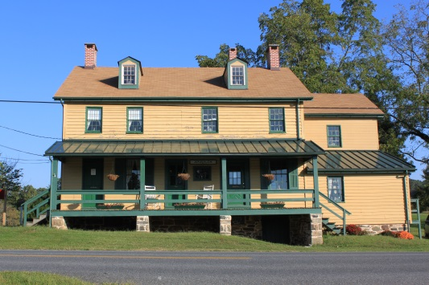

The General Store, Civil War Room and Gift Shop are open on Saturdays and Sundays from 1 p.m. to 4 p.m. Learn about the village’s connection to the Civil War, step into a 1930s general store, and browse our gift shop for a variety of souvenirs including items made by our own blacksmiths.

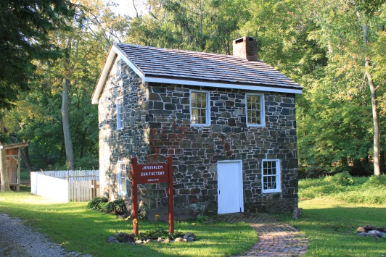

The Miller’s House (a.k.a. “the gun shop”) is open on Sundays from 1 p.m. to 4 p.m. Watch Living History interpreters demonstrate hearth and open fire cooking, gardening, sewing or other activities of daily life in Colonial times.

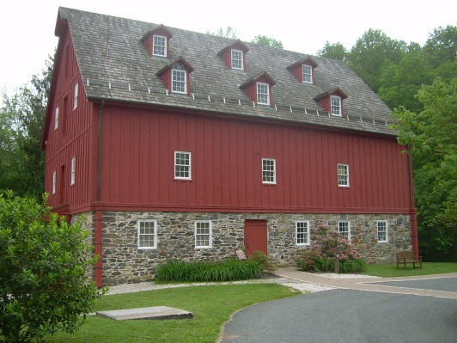

The Grist Mill (Visitor Center and Museum) is open on Saturdays and Mondays from 10 a.m. to 4 p.m., Sundays and Fridays from 1 p.m. to 4 p.m. Learn about the village, explore our artifacts, and see how a 1772 grist mill operated.

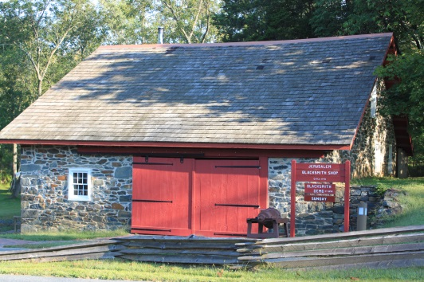

The Blacksmith Shop is open on the second Saturday of every month, from 1 p.m. to 4 p.m. See the forge in operation as our blacksmiths demonstrate their trade.

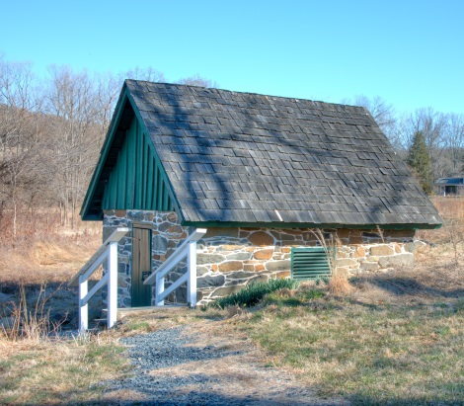

The Springhouse was used to store perishable dairy products and other food items. A spring maintains a year-round temperature of 56 degrees. The Springhouse is open on Saturdays and Sundays from 1 p.m. to 4 p.m.

Thanks to our Sponsors

We are sincerely grateful to our sponsors for their generosity, enthusiasm, and belief in our mission! We encourage all of our visitors to patronize our sponsors’ quality services and products. To inquire about sponsoring our many activities and events, e-mail us at jerusalemmill@yahoo.com !

Welch Mechanical Designs, LLC
Designers and manufacturers of high-quality, high-precision optical systems for commercial, military and scientific applications.
1200 Technology Drive, Suite N
Aberdeen, MD 21001 410-698-3024
https://www.wmdllc.com/

Sunshine Grille Bistro and Catering
Greek and American cuisine in a casually elegant atmosphere.
12607 Fork Road, Fork, MD 21051
410-592-3378

Wirtz & Daughters Garden Center
Visit us or use our delivery service for mulch, sand, soil, or stone products.
12140 Pulaski Highway, Joppa, MD 21085
410-335-1278 wirtz.kellyb@gmail.com
www.wirtzanddaughters.com

Walter G. Coale, Inc.
New Holland tractors, Mahindra tractors, Lawn care equipment, trailers and snow removal equipment for sale
2849 Churchville Rd, Churchville, MD, 21028 410-838-3500
ray@waltergcoale.com
www.waltergcoale.com

Mr. David Marks
Baltimore County Councilman
400 Washington Ave.
Towson, MD 21204
410-887-3384
davidmarks@verizon.net

It’s All Fun & Games Day Camp
Everything a camp should be!
Located in the Valleybrook Country Club
1810 Valleybrook Drive, Kingsville, MD, 21087 410-879-4460

Bel Air Dental Care
2300 Belair Road, Fallston, MD 21047
410-879-8424
www.belairdental.com

Harry and Scott Sanders
Long and Foster Realtors
Bringing a heritage of quality to Baltimore and Harford County real estate.
12514 Jerusalem Road, Kingsville, MD, 21087
www.come2md.com
410-515-7400

Lassahn Funeral Home
Heather Lassahn
11750 Belair Rd, Kingsville, MD 21087
410-665-2000
hlassahn@lassahnfuneralhomes.com
www.lassahnfuneralhomes.com

Feild Family Dentistry
Gentle Dental for the Whole Family
Drs. Paul & Matt Feild, DDS, PA
12619 Harford Road, Fork, MD 21051
410-592-5420
pefdds@aol.com
www.feildfamilydentistry.com

Yox’s Yard
Small engine and lawn equipment maintenance
12210 Pulaski Hwy., Bldg C
Joppa, MD 21085 410-977-5511
Yoxs.Yard@gmail.com

First Home Mortgage Corp.
Ann E. Parlang
5355 Nottingham Drive, Suite 115
Baltimore, MD 21236
apalrang@firsthome.com
www.firsthome.com/loanofficers/ann
410-336-2667

Kingsville Auto Repair
Terry Heil
12116 Belair Rd., Kingsville, MD 21087
kingsvilleauto@comcast.net
www.kingsvilleautorepair.com
410-592-7172
G&M Automotive
George Majchrzak
11825 Belair Rd., Kingsville, MD 21087
gmajchrzak@gmautomotive.com
www.gmautomotive.com
443-622-9564

Corbin Fuel Co., Inc.
Greg Ensor
P.O. Box 689
Bel Air, MD 21014
www.corbinfuel.com

Alianiello Eye Care
Bob Alianiello
11824 Belair Rd.
Kingsville, MD 21087
drrga@yahoo.com
www.alianielloeyecare.com
410-593-9898

There’s room for your listing here!

To become a sponsor, send us an e-mail at jerusalemmill@yahoo.com or call us on
410-877-3560.

This newsletter is also supported by a grant from the Maryland State Arts Council and the Harford County Cultural Arts Board.

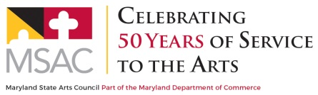
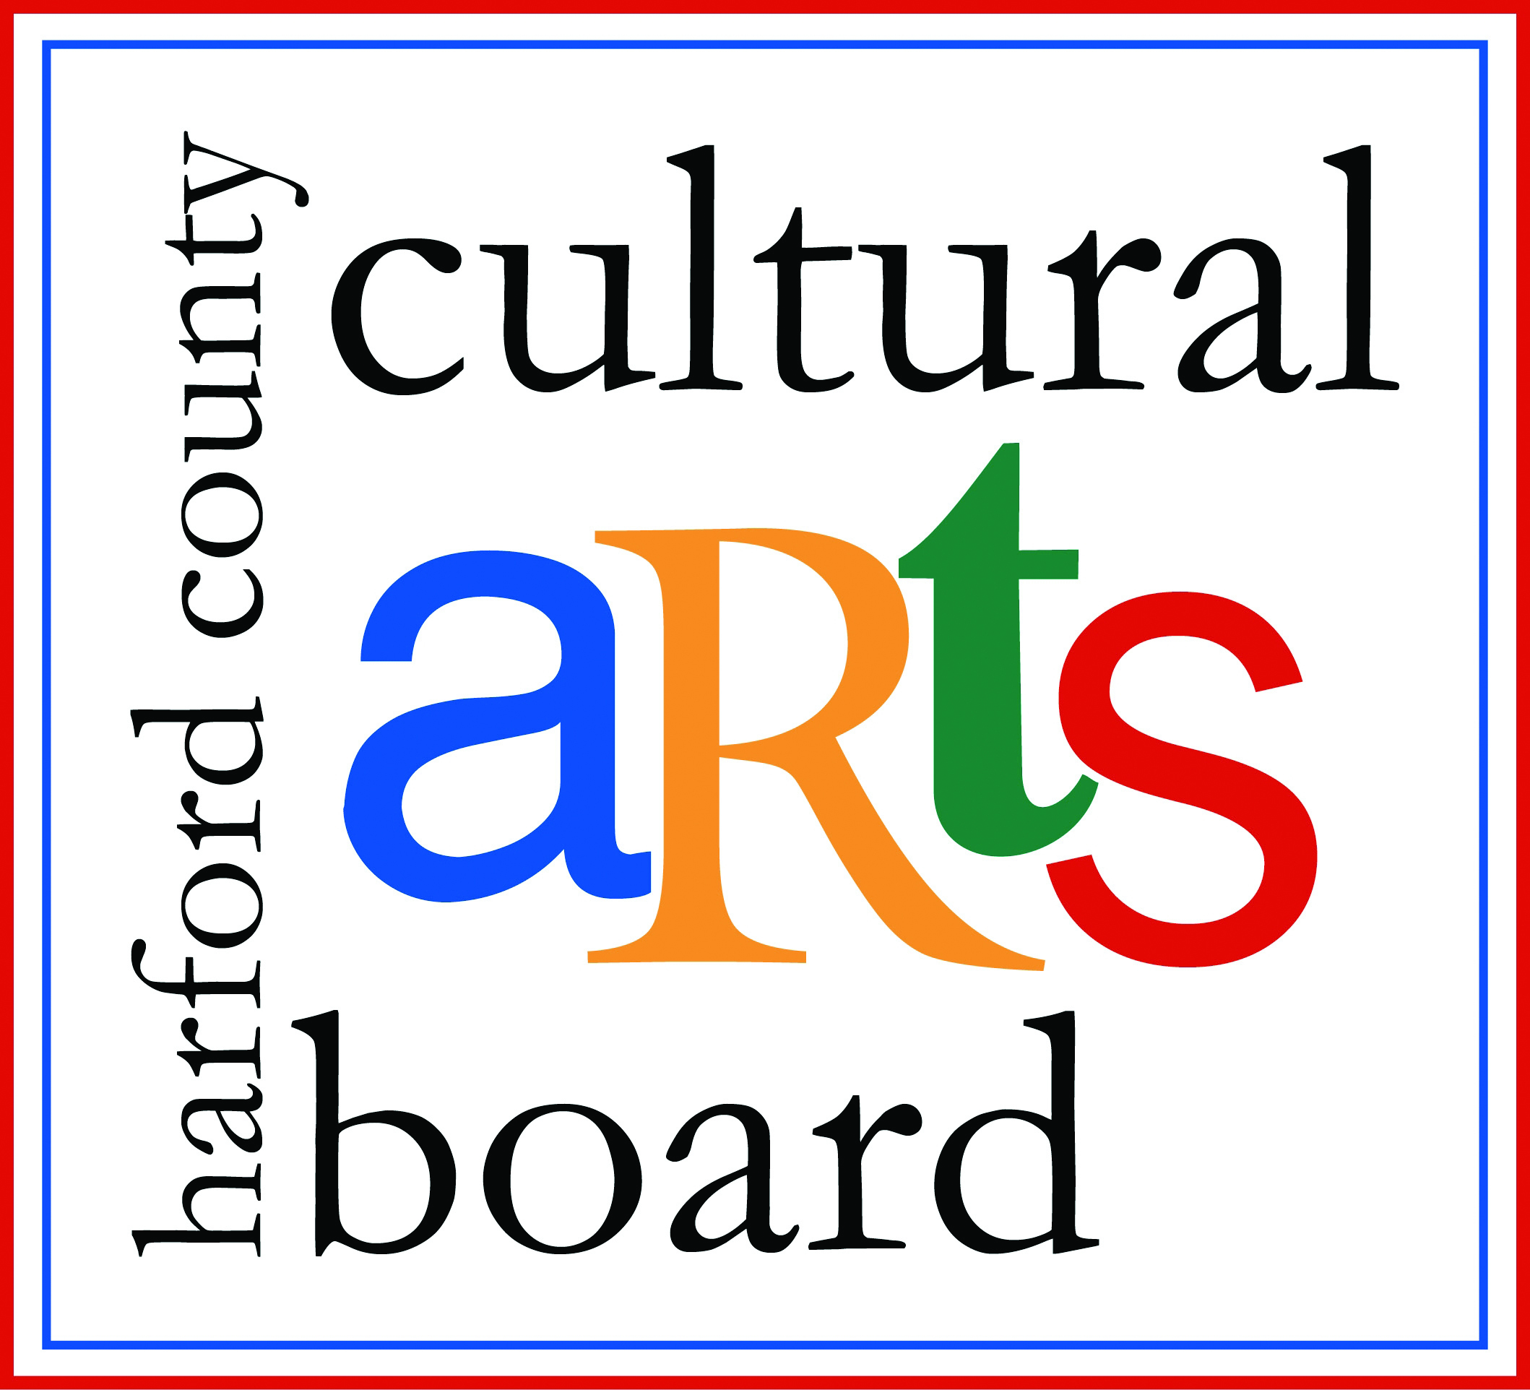

Special thanks to the Harford County Special Grants, Cultural Grants, and Office of Economic Development for their continued support!

