The Gristmill Gazette
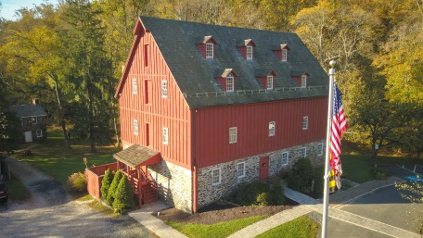
Jerusalem Mills Village
News & Notes
Summer 2018

Upcoming Events

July 5th MD Army National Guard free concert in the meadow. 6:30 PM.

July 7th Yard Sale (rescheduled from June 9th)

July 14th Second Saturday Serve volunteer day.
9 AM – Noon.

July 15th Riverside Carnival Band, New Orleans/Dixieland Jazz. 6-8 PM. $

July 21st George Kreutzer Memorial Joust (rescheduled from June 23rd); 10 AM.

August 4th First Responder’s Day with Smack Down contest between KVFC, JMVFC, DNR

August 5th Great Train Robbery concert.
6-8 PM. $

August 11th Second Saturday Serve volunteer day. 9 AM – Noon.

August 18th Jerusalem Mill Jousting Tournament. 10 AM

August 19th The Beach Bumz – Jimmy Buffett Tribute Band. 6-8 PM. $

August 25th Vintage Baseball games in the Village – 1860s-style.

September 22nd Amateur Jousting Club Championship Joust – 11 AM

Details on all of our events are available on our web page at www.jerusalemmill.org.
In the Spotlight:
The Joinery

By John Peeler

We’re proud to introduce the newest addition to our Living History program: the Jerusalem Mills Joinery! Located in the Carriage House next to the mill, it opened to visitors in February, 2018. Right now, all historical interpretation happens in the front room of the first floor, and focuses on colonial era woodworking.

The name “Joinery” comes from the work done in the shop. In the world of woodworking in the colonial era, there were many individual trades open to a woodworker. Coopers made buckets and barrels. Wheelwrights made wheels and anything that uses wheels, like carriages and wheelbarrows. Carpenters worked with logs and timbers, building houses and outdoor structures. Cabinetmakers built fine furniture and had other specialties. Somewhere in the middle of all that, the joiner did his work.

The focus for colonial joinery was on production of everyday commodity items like boxes, utilitarian furniture, and implements, using the shaping of wood to affix pieces together. They did everything from making complicated crown moldings to producing kitchen tables and other common furniture.

In the Joinery at Jerusalem Mills, our joiner focuses on interpreting what it means to be a joiner in colonial times, and how that differs with modern woodworking. The tools involved now “decorate” the Joinery walls for the visitors’ viewing pleasure, but are put to use often.

In the joiner’s shop the use of hand planes, saws, chisels, and other tools are demonstrated to show visitors how a rough plank of wood is made flat and square, then how joints like the dovetail, tongue-and-groove, rabbet, and mortise-and-tenon are employed to build without the use of fasteners like nails or screws. The myriad of tools in the shop often have very specific uses, and can be as complicated as a plow plane (for cutting grooves in a board) or as simple as a hand axe (for rough hewing of wood before it is brought to the bench).

Woods commonly available in colonial times in this part of America were pine, poplar, red oak, white oak, ash, elm, cherry, mahogany, and walnut, to name a few. Each had a favored use, whether for rough construction timber or fine cabinet-grade wood. The hardness, flexibility, visual appeal, and many other characteristics go into making a decision on what to use, but historical joiners also had to use whatever was available.

The Joinery is open for visitors from 1 to 4 on Sundays, and by special appointment. It has also been added as a “station” in our Education program, and in May our joiner demonstrated his craft to hundreds of school children, and had a special visit from Gunpowder Falls State Park personnel. In July the joinery will be hosting a visit from students from the National Center for Blind Youth involved in a study of timber frame buildings.

Improvements to the Joinery and Carriage House will be starting this summer, including a partial siding pull to return the building to a more authentic look. A new workbench to replace the authentic but aged bench in use will soon be in the works as well. Stop by any Sunday to check out our progress!

Editor’s comment: We are very fortunate to have John Peeler join our volunteer staff as the new joiner. We appreciate all his efforts in completing the joinery and adding another very interesting craft to our living history program.
Meet Our Visitor Center and Museum Volunteers

We are very fortunate to have some new volunteers on our Visitor Center – Museum (VC-M) docent staff this year. In our Spring 2018 newsletter and at the Spring Dinner we acknowledged Chris and Joan Scovill for their many years of service in various capacities within the organization, and particularly for their contributions to the Visitor Center – Museum. In this issue we want to include a brief introduction to the volunteers who have joined Chris and Joan as members of the docent staff.

Bill Chambers has been volunteering in several capacities for about 7 years. He is a current Board member of the Friends of Jerusalem Mill, and the Vice President of the Percy Lee Dairy Farm Foundation. Bill is also our resident magician, performing his magic at a wide variety of events. Bill works in the VC-M on Sundays from 10 AM to 1 PM.

Bill Clark: The Clark family has lived up the hill from Jerusalem Mill at Aesopstables since 1989. They became life members of the Friends of Jerusalem Mill back in 1991 because it was a deal they could not resist. They became connected to the Mill because the person that sold them their new home was none other than Harry Sanders, the founder of The Friends of Jerusalem Mill! Bill believes that what makes the volunteering so gratifying is to see how the community comes together in support of everything going on. In the VC-M you’ll see Bill’s signature on a 1992 certificate of appreciation from the Little Falls Meeting of the Religious Society of Friends, on display. Bill works in the Visitor Center – Museum on the first Saturday of every month, from 10 AM to 1 PM.

David and Betty Ewing can usually be found in the Visitor Center – Museum every second Saturday, from 10 AM to 1 PM. David has the unique perspective of having lived in the village. As a child he lived with his family in “the miller’s house”, the little stone house behind the grist mill. He gladly shares his first-hand knowledge of the village and its operations.

John B. Gontrum’s grandfather, John F. Gontrum, was counsel to the Baltimore and Jerusalem Turnpike Company when they made major repairs to the road between Baltimore and Jerusalem Mills (much of which is now Belair Road). John B. Gontrum’s father, John H. Gontrum, was a major proponent of the establishment of the Gunpowder Falls State Park as a member of the citizen’s advisory committee. The Gontrums were also regular customers of the Jerusalem Mill. John greets visitors to the VC-M on the 4th Saturday of every month, from 10 AM to 1 PM. The Gontrum safe and a share certificate from the Turnpike Company are on display in the Visitor Center – Museum.

Barb Pumphrey’s mother’s family lived in Kingsville for many generations. Her great grandfather had a blacksmith shop at the corner of Jerusalem and Bradshaw roads (the building later became a car dealership). Barb has been volunteering four years doing lawn maintenance and enjoys her weekly soiree around the village grounds on the riding mower. She will be working in the VC-M whenever there’s a fifth Saturday in the month, from 10 AM to 1 PM.

Edna Davenport has been a member of The Friends of Jerusalem Mill for many years, and has lived in the area all of her life (except for 20 years as a military wife). As a child Edna spent many hours in the summertime playing on the covered bridge, swimming in the Little Gunpowder, and walking to the mill to buy corn for their chickens and ducks. Edna’s daughter and son-in-law, Sherry and Jerry Backof are retired educators from Baltimore County. Jerry also worked for the National Park Service at Ft. McHenry. The three of them are usually available on the second Friday of every month, from 10 AM to 1 PM.

The Visitor Center – Museum is generally open on Saturdays and Sundays from 10 AM to
4 PM, and Mondays and Fridays from 1 PM to
4 PM (10-4 on the second Friday of the month), depending on the availability of volunteers. We hope to recruit more volunteers to extend our hours even further!
A Tale of the Traveling Barrels

By Suzanne Zacker

What do three local theaters, song and dance numbers, and historical plots have in common? The answer: two nail barrels from Historic Jerusalem Mill. This spring, three local community theaters included our nail barrels as stage props in their 2018 season productions.

First, Artistic Synergy of Baltimore, in residence at Prince of Peace Lutheran Church in Rosedale, presented a fine production of Oklahoma! by Rogers and Hammerstein. Next, the Waldorf School of Baltimore performed a fun student production of Anne of Green Gables by Lucy Maud Montgomery. Finally, Tidewater Players, housed in the Havre de Grace Opera House offered a rousing performance of 1776 by Sherman Edwards.

The three production companies have expressed their appreciation for the loan of the items from the general store museum. The village received publicity with acknowledgements in the playbills. This is a fine example of sharing and outreach to our community by Historic Jerusalem Mills. We feel proud about supporting these local nonprofit community theaters.
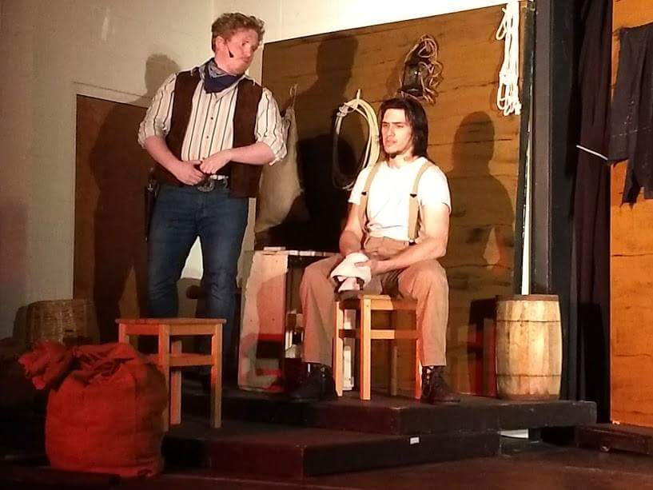
Oklahoma! Prince of Peace Lutheran Church
Blacksmith Shop Renovations

You may have noticed that the blacksmith shop is temporarily closed. As one might expect from a building that is over 200 years old, we occasionally have to do some work that goes beyond routine maintenance. The most efficient and safest way to accomplish this work is when the building is not open to visitors. Such is the case with the blacksmith shop. We appreciate your patience while we make some necessary repairs that will help us preserve this village treasure for many years to come. We assure you that we’ll reopen it as soon as possible. An exact date has not been determined.
Where’s the Falls?

The second most frequently asked question by visitors entering our Visitor Center - Museum is “Where’s the Falls?” The most direct answer to that question would be to simply look out the window, point to the water flowing past the mill, and respond: “Right there!” Although many people refer to the waterway as “The Little Gunpowder River”, it’s actually called “The Little Gunpowder Falls”, just as its bigger sibling several miles south on Belair Road is officially named “The Big Gunpowder Falls”. They are both appropriately named because of the drop in altitude as the river flows from the Piedmont Region in the west to the coastal area in the east. The resulting “fall” is significant enough to qualify as a falls.

However, if you are looking for a more traditional waterfall, you only have to drive about 5 miles from Jerusalem Mill Village, then hike about ¾ of a mile to reach a beautiful cascading waterfall along the Dick Branch as it sends water to The Little Gunpowder Falls.

The Dick Branch falls is a pair of 10 foot cascading waterfalls that are a very short distance from each other. To get to the Dick Branch Falls, park at the parking area on Harford Road on the west side of The Little Gunpowder Falls, and take the trailhead heading north from the parking area. You’ll have to make one stream crossing across some rock stepping stones, but otherwise it’s a fairly level and easy hike to the falls. There is a slight increase in elevation as you walk away from the Little Gunpowder toward the falls, along the Dick Branch. Since the falls are located a short distance “up” the Dick Branch you have to take care to follow the white blazed trail so you don’t miss the falls. Bikers have made a shortcut across the Dick Branch where it meets the Little Gunpowder, and it’s easy to mistake that shortcut for the blazed trail. If you follow the white blazes it’ll take you right to the falls, and you’ll cross the Dick Branch “above” the falls.
A view of the Dick Branch falls in winter.
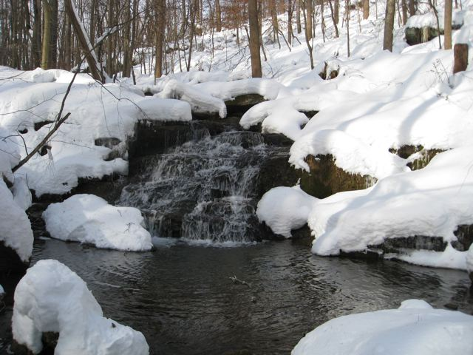
Coming Soon

Every year the Gunpowder Falls State Park sponsors one or more teams from the Maryland Conservation Job Corps (known as the CJC). According to the program description, the participants in the program “…gain skills that prepare them for many career opportunities and a lifetime of healthy outdoor recreation and interaction with nature.” The Friends of Jerusalem Mill often assists the park by preparing suggested project proposals for consideration. This year, several of our submissions were accepted, and by the time you read this article the program participants will have already started their work in the village. The first project they’ll work on is a footprint of the Jericho Saw Mill, immediately adjacent to the Grist Mill. The saw mill was intentionally located on a hill so access could be made on two levels without exterior ramps or steps. The CJC team will also take the opportunity to build a set of steps next to the 54’ long footprint, for safer access to the lower picnic area.

Other projects we hope to complete include an extension of the gravel trail from the paved parking lot to the Jerusalem Mill Trail (blue blazes), an extension to the gravel portion of the Little Gunpowder Trail (white blazes) as it traverses the former mill race, amphitheater seating for outdoor presentations, installation of water bars for better drainage on the westernmost portion of the “track” around the former orchard, and removal of invasive plants (mostly multi-flora rose) from various locations.
We Need Your Help

As a non-profit charitable organization we rely on generous donations of time and money from our many volunteers and donors to accomplish our mission of preserving and presenting local history. During this time of year we particularly need help with lawn and garden maintenance – just an hour each week is a big help. We also need more docents, special events organizers and staff, costumed interpreters, researchers and curatorial assistants, and more. Financial contributions can be made through individual or family memberships, business sponsorships, building or maintenance fund donations (cash, check or charge cards), selection of the Friends of Jerusalem Mill as the charity of choice when you purchase through AmazonSmile, etc. You can get more information on all of these opportunities at www.jerusalemmill.org, e-mail us at jerusalemmill@yahoo.com, or call us on
410-877-3560. Sponsorship and membership forms are also available on www.jerusalemmill.org.

Massive Yard Sale

On Saturday, July 7th, from 8 AM to 2 PM, The Friends of Jerusalem Mill will hold its semi-annual yard sale on the village grounds, between the paved parking lot and the general store. We have hundreds of items for sale to include tools, hardware, sporting goods, books, furniture, small appliances, household goods, cookware, toys, luggage, and a whole lot more. All of the proceeds benefit the continued maintenance, operation, and reconstruction of the historic Jerusalem Mill Village. Additional donations of sale items will be collected until 9 AM Saturday morning. Items not sold during the yard sale will be donated to one or more of the local charities.
To contact the newsletter editor, send an e-mail to jerusalem.mill.curator@gmail.com, or call the Visitor Center – Museum at 410-877-3560.
To cancel your free subscription, send an e-mail to gristmillgazette@yahoo.com with a subject line of “unsubscribe” and list the e-mail address to delete in the body of the e-mail. To add an
e-mail address to our quarterly distribution list, send an e-mail to gristmillgazette@yahoo.com with “subscribe in the subject line and list the
e-mail address to be added in the body of the
e-mail.
We are sincerely grateful to our sponsors for their generosity, enthusiasm, and belief in our mission! We encourage all of our visitors to patronize our sponsors’ quality services and products. To inquire about sponsoring our many activities and events, e-mail us at jerusalemmill@yahoo.com !

Welch Mechanical Designs, LLC
Designers and manufacturers of high-quality, high-precision optical systems for commercial, military and scientific applications.
1200 Technology Drive, Suite N
Aberdeen, MD 21001 410-698-3024

HCF&L P.A.
Handwerger, Cardegna, Funkhouser & Lurman, P.A. is a full service tax, accounting, and business consulting firm.
1104 Kenilworth Drive, Suite 300
Towson, MD 21204 410-828-0226

Sunshine Grille Bistro and Catering
Greek and American cuisine in a casually elegant atmosphere.
12607 Fork Road, Fork, MD 21051
410-592-3378

Wirtz & Daughters Garden Center
Visit us or use our delivery service for mulch, sand, soil, or stone products.
12140 Pulaski Highway, Joppa, MD 21085
410-679-6700 wirtzleahl@gmail.com

Walter G. Coale, Inc.
New Holland tractors, Mahindra tractors, Lawn care equipment, trailers and snow removal equipment for sale
2849 Churchville Rd, Churchville, MD 21028 410-838-3500

TSW Roofing Solutions
1615 Robin Circle, Suite G
Forest Hill, MD 21050
410-979-7876

Joppatowne Garden Club
Perry Hall, MD 21128
410-698-5786

Friends of David Marks
Baltimore County Councilman
councilmanmarkscampaign@gmail.com
Lassahn Funeral Home
7401 Belair Rd, Baltimore, MD 21236
410-665-2000
hlassahn@lassahnfuneralhomes.com

Bel Air Dental Care
Alan Scharf, DDS and
Gregory Indyke, DDS
2300 Belair Road, Fallston, MD 21047
410-679-6700 or 410-879-8424

Corbin Fuel
Blue Ribbon pricing and service!
33 East Ellendale Street
Bel Air, MD 21014-0689
410-879-0579, 410-838-3590, or 1-800-474-3590

Reds Wine and Spirits
Catering, Deli, Prepared Foods, Butcher – Fresh Cut Meats, Wine, Beer, Liquor, Groceries, ATM, Lottery, Propane
12037 Belair Road, Kingsville, MD 21087
410-592-6202

It’s All Fun & Games Day Camp
Everything a camp should be!
Located in the Valleybrook Country Club
1810 Valleybrook Drive,
Kingsville, MD 21087
410-879-4460

Party Party
Your total party headquarters!
222 Commerce Road, Forest Hill, MD 21050
410-893-3321

Gunpowder Lodge
Unique neighborhood restaurant & bar tucked alongside the Gunpowder River.
10092 Belair Road
Kingsville, MD 21087
410-256-2626

Feild Family Dentistry
Gentle Dental for the Whole Family
Dr. Paul E Feild, DDS, PA
12619 Harford Road, Fork, MD 21051

Pete’s Pickins Antiques and Collectables
Over 40 years of experience buying and selling quality antiques!
7901 Bradshaw Road,
Upper Falls, MD, 21156
410-592-6884 or 410-592-5420

Prosperity Home Mortgage, LLC
Put Prosperity in your life!
Joseph H. Bragg, III, Home Mortgage Consultant (NMLSR #209891)
3004 Emmorton Road,
Abingdon, MD 21009
410-515-6007

Harry and Scott Sanders
Long and Foster Realtors
Bringing a heritage of quality to Baltimore and Harford County real estate.
12514 Jerusalem Road,
Kingsville, MD 21087
410-592-6751

Maryland Army National Guard Recruiting and Retention NCO SGT Kimberly Kerschner
4244 Montgomery Rd
Ellicott City, MD 21043
443-789-9269
Kimberly.D.Kerschner.mil@mail.mil

The Flanders Group
Wealth Management, CPA,
and Tax Service
221 Maitland Street, Bel Air 21014
Telephone: 410-569-4506
Email: info@flanderscpa.com

Yox’s Yard
Small engine and lawn equipment maintenance
12210 Pulaski Hwy., Bldg C
Joppa, MD 21085
410-977-5511
Yoxs.Yard@gmail.com
Gallup Well Services
Well pumps, water treatment, pressure tanks, plumbing
Telephone: 410-321-7244
e-mail: brucehgallup@gmail.com
contact: Randall McGill

Cherokee Raiders
Non-profit organization; Western and English equestrian show series.
608 N. Tollgate Rd., Bel Air, MD
cherokeeraiders@gmail.com

Amateur Jousting Club of Maryland
e-mail: phoffman12@verizon.net

Bmore Electric LLC
Edgewood, MD 443-243-8464
Electricalcontractoredgewood.com

K.P. Hubers Produce Farms
7110 Mt. Vista Rd., Kingsvill, MD
410-593-9670

Dunk’n Donuts
1920 Belair Rd., Fallston, MD
410-877-2445

Chesapeake Nine of Baltimore
Vintage Baseball Team (19th century)
Contact: jtstanik@att.net
www.Mavbbl.com/capitol-conference/chesapeake-nine-of-baltimore/

This newsletter is also supported by a grant from the Maryland State Arts Council and the Harford County Cultural Arts Board.

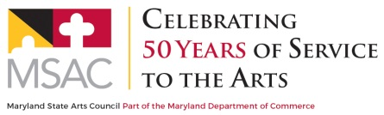
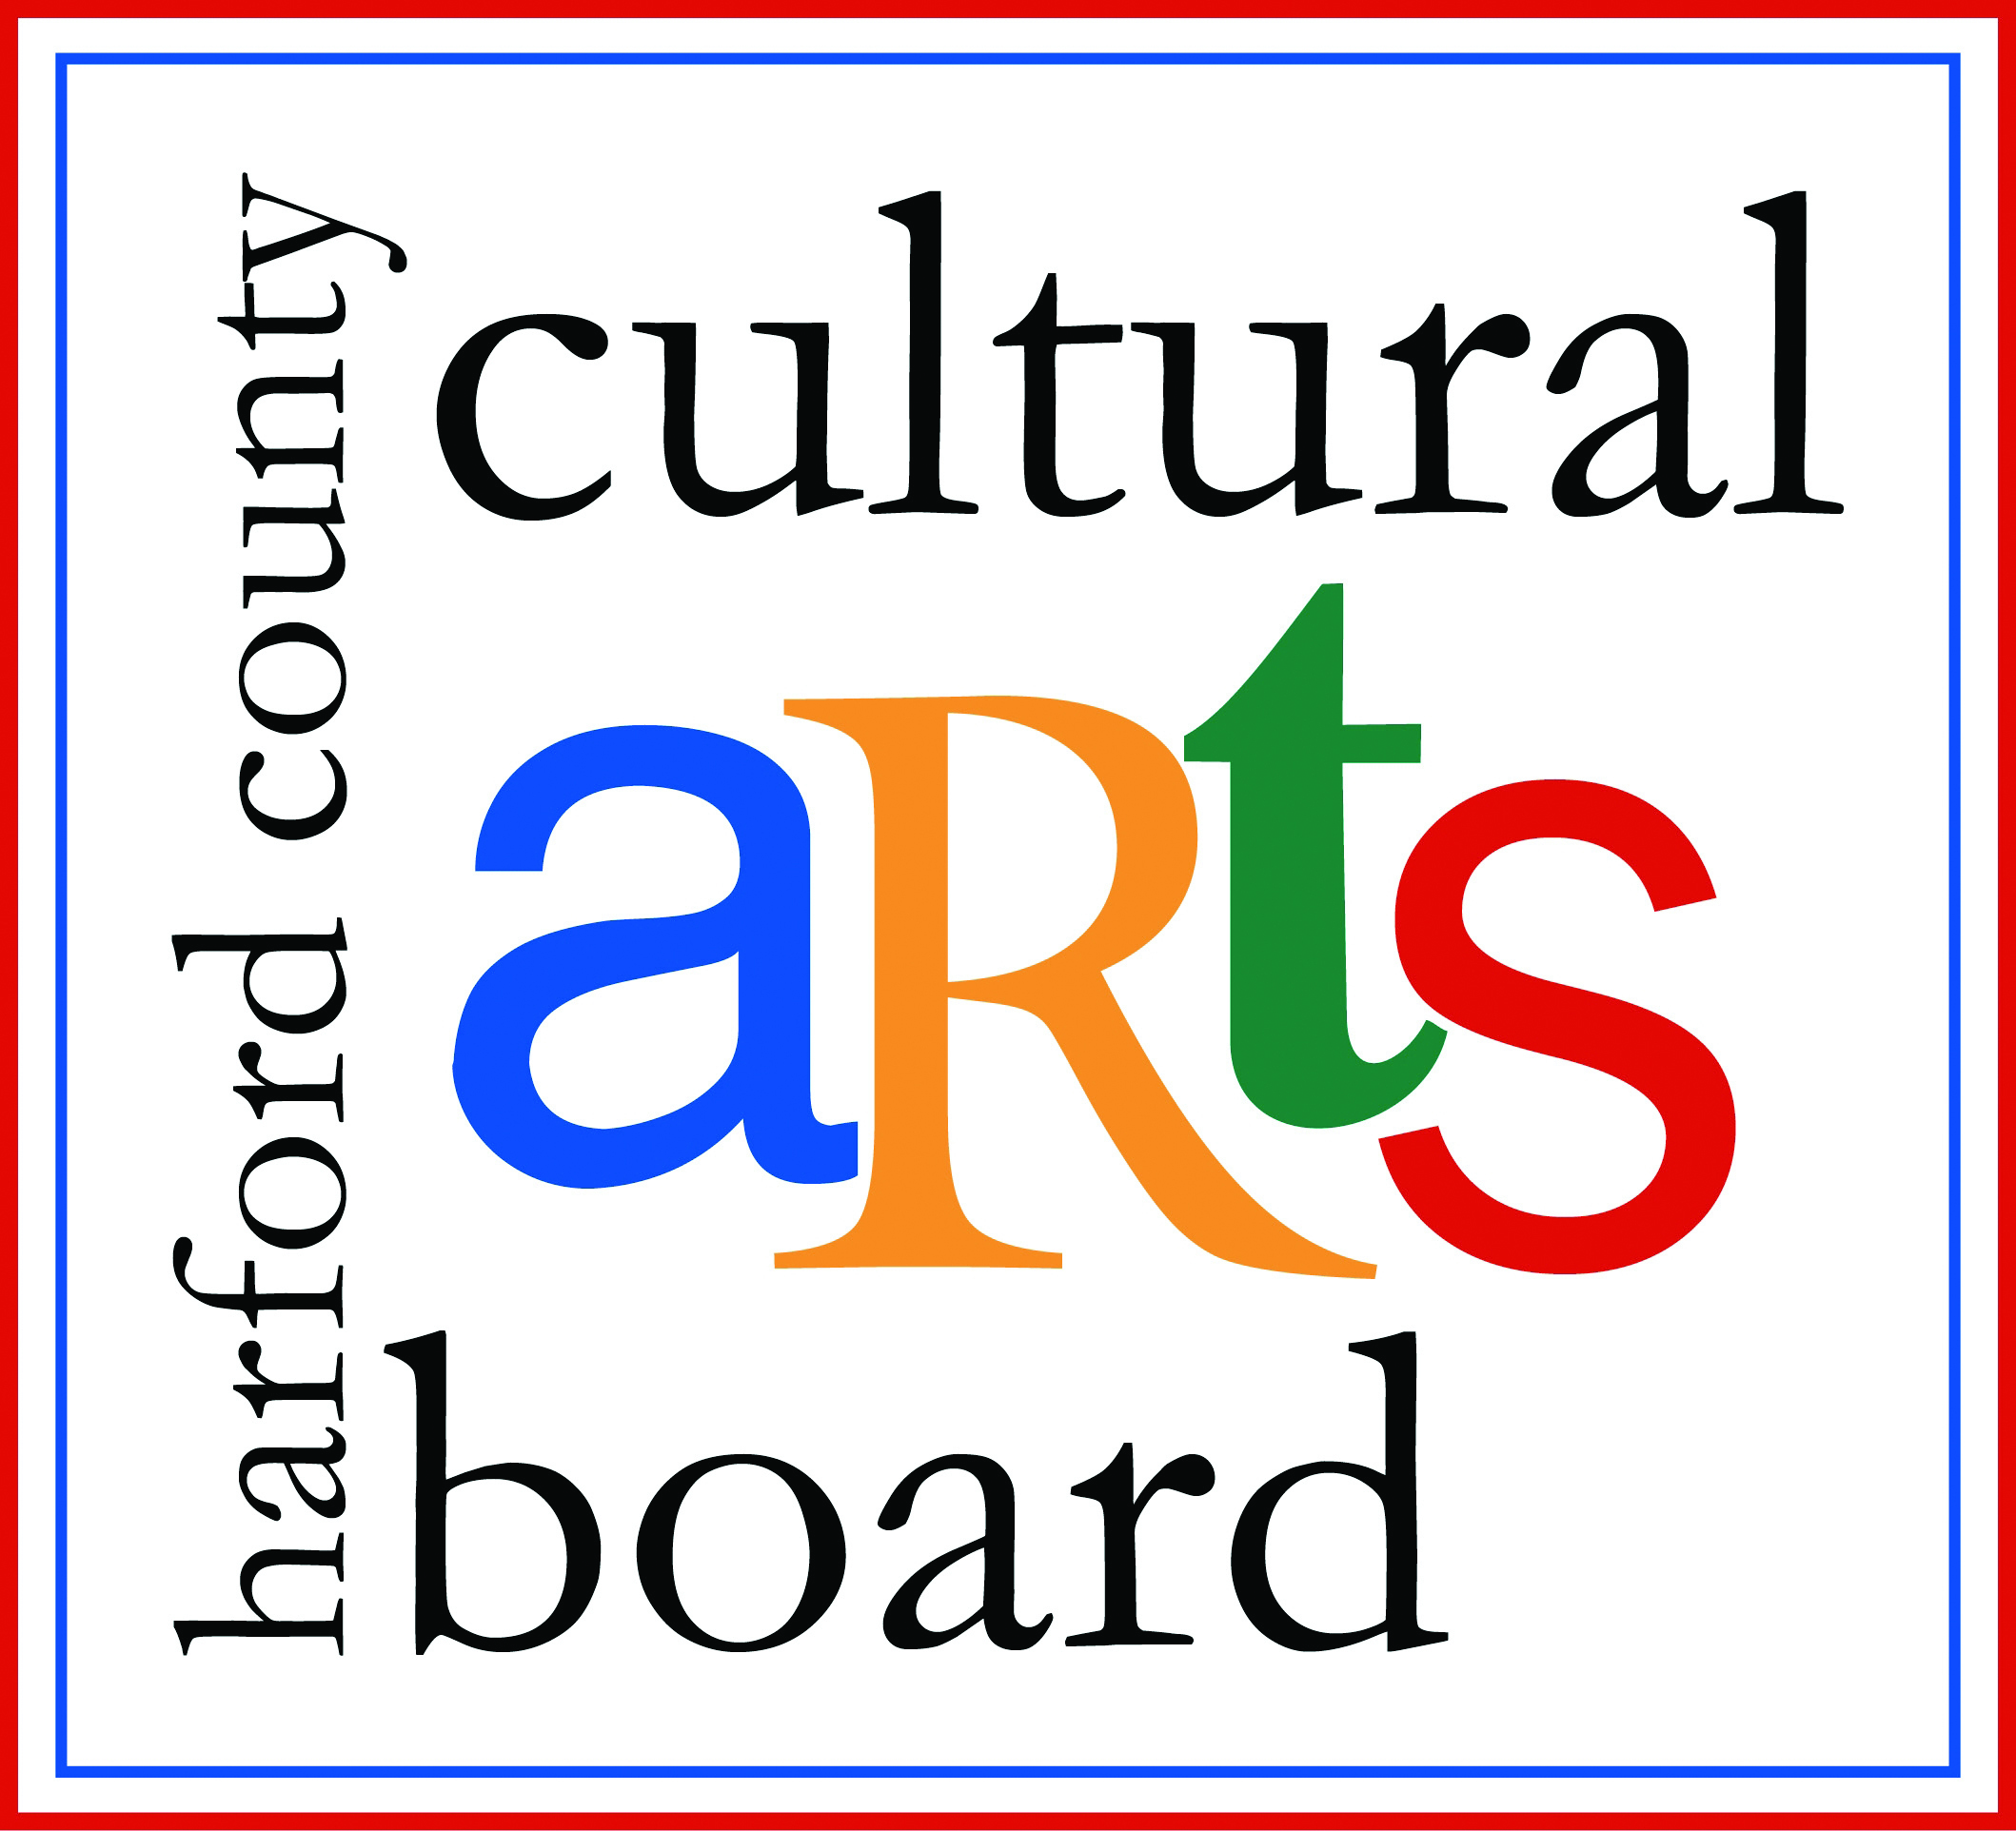

Special thanks to the Harford County Special Grants, Cultural Grants, and Office of Economic Development for their continued support!

