The Gristmill Gazette
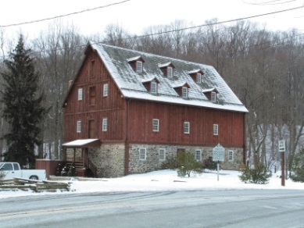
Jerusalem Mill Village
News & Notes
Fall 2018

2811 Jerusalem Rd., Kingsville, MD www.jerusalemmill.org 410-877-3560

Upcoming Events

October 11th & 18th – Volunteers needed to cut grass in the village. 8:30 a.m. to 12:30 p.m.

October 13th – MD Public School Gunpowder Invitational Cross-Country Meet. 7 a.m. to 1 p.m.

October 13th – Fairy Tales to Scary Tales Family Haunted Trail. 3 p.m. to 7 p.m.

November 10th – Second Saturday Serve volunteer day. 9:00 a.m. to noon. All volunteers welcome.

November 10th – Village Yard Sale. 8 a.m. to 2 p.m.

November 10th – Blacksmith Demonstrations. 1 p.m. to 4 p.m.

November 17th – Little Gunpowder 50K Race. 8 a.m. to 6 p.m.

December 7th – Gunpowder Falls State Park Volunteer Breakfast. 8 a.m. to 11 a.m.

December 7th – FOJM Pot Luck Dinner and Village Future Planning. 6 p.m. (see article on page 4)

December 8th – Second Saturday Serve volunteer day. 9:00 a.m. to noon. All volunteers welcome.

December 9th – Christmas in the Village. 10 a.m. to 4 p.m.

January 1st – First Day Hike. Start times are 9 a.m. and 1 p.m.

Details on all of our events are available on our web page at www.jerusalemmill.org.
In the Spotlight:
First Responders’ Day

The fourth Annual First Responders’ Day was celebrated on Saturday, August 18th from 11 a.m. to 3 p.m. The many activities included simulated fire suppression for children, community outreach, Harford County Sheriff's Office K9 Demonstration, Maryland State Police helicopter visit, and the annual “Smack Down” contest between Kingsville Volunteer Fire Company, Joppa-Magnolia Volunteer Fire Company, Maryland Park Service and the Maryland Department of Natural Resources Police.

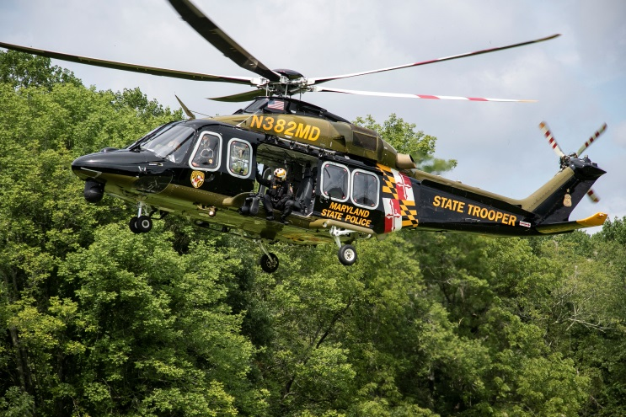
Photo by Jack Benesch

Special activities this year included an opportunity for the Girl Scout Brownies to earn Pets try-it badge as part of Shae Steven's gold award project; Harford County Humane Society booth; and the Chesapeake Search Dogs. Catering was provided by Reds of Kingsville. Ben's Auto and Wirtz & Daughters contributed to a $1,000 cash price for the Winner of the Smack-down. The First Place prize went to Kingsville Volunteer Fire Company and the runner-up was Joppa Magnolia Volunteer Fire Company. Hundreds of visitors enjoyed the event.

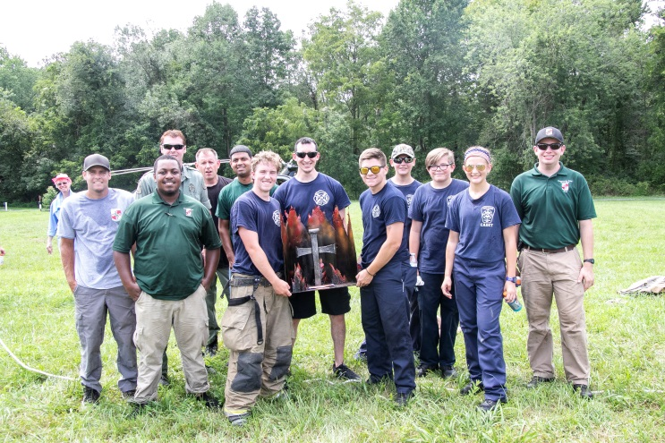
2018 “Smack Down” Participants
Photo by Jack Benesch
Why does the trail flood?
by Will Sade

This is a question that I hear often while working at Jerusalem Mill Village. Many park visitors visit the village to hike the Little Gunpowder Trail along the Little Gunpowder Falls which defines the border between Baltimore and Harford Counties. This trail happens to be the most popular pathway in the village, but are you aware of its historical significance? A section of the trail that predates the creation of Gunpowder Falls State Park was actually a channel used as a water race to carry water captured by a dam and direct the water to the mills. This water source was used to power the Lee Merchant Mill and the Jericho Saw Mill. It is amazing that several sections of this head race are still intact and can be identified along the river. It is this section of trail that follows the path of the head race that floods after heavy rains, because it was designed to hold water!

Built about .4 of a mile upstream from the mill, the dam was very unimpressive. It was constructed of logs and lasted until the mid- to late-1930s, when it was destroyed by flood waters during a hurricane. After the flood the mill’s water wheels were replaced with electric turbines, and therefore a water source was no longer needed for power.

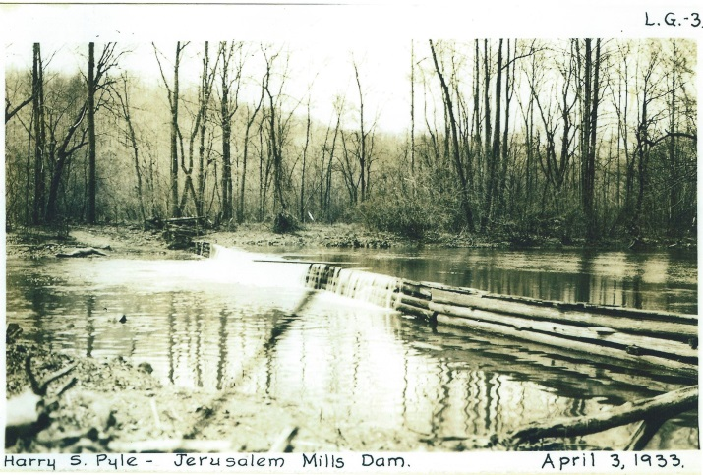

As you walk along the “race” portion of the trail a stone “waste gate” is still visible near the first wooden bridge-crossing on the trail. The waste gate was used as a relief valve during periods of heavy rain to avoid flooding of the race as it approached the mills. Not far from the waste gate was an ice pond that was fed by a natural spring. This pooled water would freeze during the winter and was harvested to be used in an underground ice house for food storage.

The “head” race ended at the front of the mill, where a gravel path now marks the location to the right of the front door. Looking across the street from the mill, one can see the remains of the hand-dug mill race to the right of the blacksmith shop.

This one example of finding remnants of industrial infrastructure is not a unique instance at Jerusalem Mill. Hidden in plain sight within the beauty of Gunpowder Falls State Park, visitors may come across remains of long-gone industry dotting the landscape of the Gunpowder River Valley.
FoJM Hosts National Center for Blind Youth
by John Peeler

On July 31st, Jerusalem Mill Village volunteers hosted students from the National Center for Blind Youth in Science, an initiative that serves visually impaired high school students from all over America. This year, the National Federation of the Blind Engineering Quotient program’s week-long engineering camp was based in Baltimore, and their organizer made contact with the FoJM to discuss possibilities for a day visit. The week's focus for the students was related to timber frame structures - their construction and use - so Jerusalem Mill was a natural place to go for a new experience.

After a summer of planning and preparation, FoJM volunteers Rich Albright (Curator), Glenn Porter (Education Director), Hugh and Diane Pry (Miller’s House Interpreters), and John Peeler (Joiner/Carpenter) presented a short program to the 30 students, consisting of three sections: A tour of village buildings that use timber frame construction, a walking tour to experience the bank barn and Jericho Bridge, and an introduction to timber frame construction tools and techniques. Luckily, the threatening rain held off, and the students were able to experience the historical perspective that Jerusalem Mill offers.
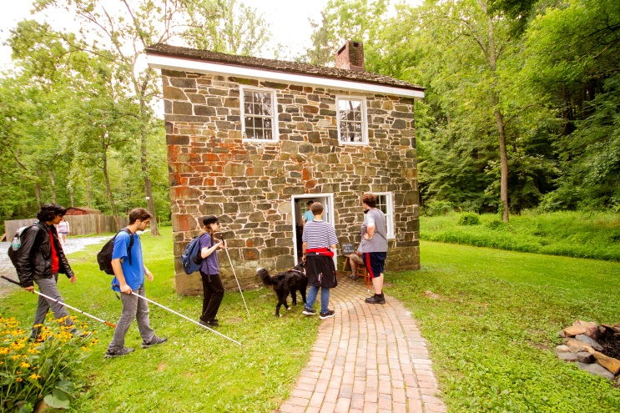
Our FoJM volunteers were happy with the experience, having learned much about working with blind students. Our visitors were also very pleased - besides the heat, getting outside and experiencing a new place can be very exciting and rewarding. If you visit the Jerusalem Mill Joinery this fall, you will see the examples and props produced for this visit, and you might even get a quick lesson on timber frame joinery yourself!"
Tell Amazon to Support Jerusalem Mill!

AmazonSmile is a simple and automatic way for you to support Jerusalem Mill Village every time you shop. Just tell Amazon to donate to The Friends of Jerusalem Mill! When you shop at smile.amazon.com, you’ll find the exact same low prices, vast selection and convenient shopping experience as Amazon.com, with the added bonus that Amazon will donate a portion of the purchase price to Jerusalem Mill. You can use the same account on AmazonSmile that you use on Amazon.

Here’s how:

To shop at AmazonSmile, simply go to smile.amazon.com from the web browser on your computer or mobile device. You may also want to add a bookmark to smile.amazon.com to make it even easier to return and continue your shopping at AmazonSmile. On your first visit to AmazonSmile, select “Friends of Jerusalem Mill Inc.” as the charitable organization to receive donations from eligible purchases before you begin shopping. Amazon will remember your selection, and then every eligible purchase you make at smile.amazon.com will result in a donation.

It’s a convenient way to do your holiday shopping and support the preservation and presentation of local history at the same time. 100% of Amazon’s donation to Jerusalem Mill will go toward the maintenance, restoration and operation of the village!
Proudly Supported by the Questers

The Questers is a non-profit organization dedicated to the study, preservation and restoration of historical sites. There are 20 chapters in Maryland and hundreds more throughout the United States and Canada. Each chapter supports a historic site. We are very fortunate that the state organization in Maryland supports Jerusalem Mill Village, and has provided resources for multiple projects in the village. The Maryland Questers 2017 Grant was for restoration of the original McCourtney's Store double front doors. This project should be completed by October 12, 2018. Their 2018 Grant was for restoration of the original chicken coop behind McCourtney's Store, which should be completed on October 14, 2018. To learn more about the great work accomplished by the Questers, please visit their web site at http://www.mdquesters.org/.
A Great Gift Idea

Here’s a great idea for a gift for someone who loves local history. We have limited edition prints of Jerusalem Mill circa 1910, by artist John Stevens. The 16 ½” x 32” print shows the former Jerusalem Covered Bridge, the grist mill and the blacksmith shop in the foreground, and a portion of the Lee Mansion in the background. Originally valued at $75.00, you can now get these beautiful prints with a donation of only $10.00, while supplies last. Matte and frame are not included.

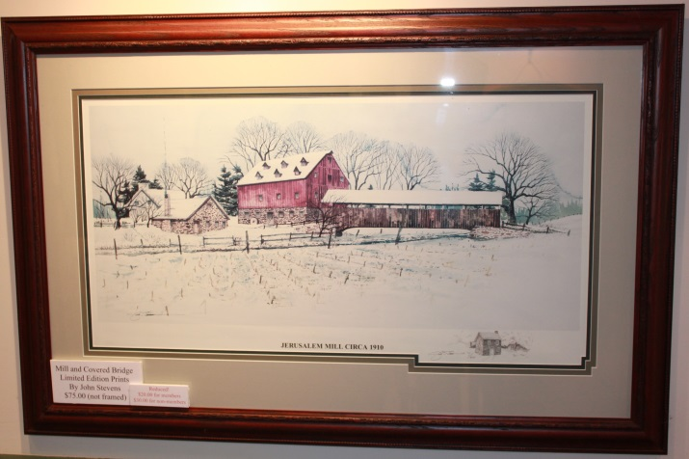

Stop in the Visitor’s Center to see other gift items.
Members’ Pot Luck Dinner

The Friends of Jerusalem Mill will host a pot luck dinner on Friday, December 7th, starting at 6 p.m. in the Christmas tent next to the blacksmith shop. All members of the Friends of Jerusalem Mill are invited to attend. Beverages and the main course will be provided. There is no admission fee, but members who attend are asked to bring a side dish or dessert. Please include a typed note listing the ingredients (for the sake of our guests who may have food allergies). This is a great opportunity to hear about our future plans and to share your own thoughts and suggestions on what is working, what isn’t working, or anything else we should consider that will make the next ten years even more successful than the last ten years!
Meet Our Volunteers

Each quarter we’ll introduce you to some of our volunteers. As a non-profit charitable organization, with no paid staff, we greatly appreciate our dedicated volunteers. We want to share their stories with you. In this edition we’ll introduce you to our two Fall interns and our two new Visitor Center – Museum docents.

Justin Opdyke is a student at Harford Community College, majoring in history. He has been working at the general store on Saturdays and will be helping with the October school groups. As a nearby Fallston resident he is intrigued by Gilmor’s Raid on the general store and is working on a Power Point presentation regarding that event. He also hopes to develop an interactive display for the Civil War Room.

Our other Fall intern is Jessica Miller, a senior at Stevenson University working on her bachelor’s degree in public history. Last year she interned at the Harford County Historical Society, and she is currently working as a research assistant for an upcoming book on the history of piracy in Maryland. Jessica’s internship in the mill will include digitizing part of our photograph collection, conducting an oral history, developing a Colonial Christmas display with hand-made decorations, designing a “touch station” for children, researching the origin of the name Gunpowder Falls, writing an article for a special holiday edition of the newsletter, one or two “tours” as a docent, and assisting in managing the operations of the Visitor Center – Museum.

We also welcome our newest Visitor Center – Museum docents, Clark and Charlotte Scott. Clark has lived in Kingsville since 1949. His wife Charlotte has been a resident of the area for the past 44 years. As a child Clark spent several years at the Upperfalls School on Franklinville Road, and one year at the Odd Fellows Hall (Raphel and Bradshaw Roads). Coming from Baltimore County, Clark’s school bus would turn around in the mill’s driveway and head back to Baltimore County. Clark is a life member of the Kingsville Volunteer Fire Company, where he served for 17 years, and his father was the last living charter member. Charlotte has also been active in the community, helping to raise funds for local support groups. Clark and Charlotte will be in the mill on the third Saturday of each month, from 10 a.m. to 1 p.m.
We Need Your Help

Because The Friends of Jerusalem Mill is a non-profit charitable organization, we rely on generous donations of time and money from our many volunteers and donors to accomplish our mission of preserving and presenting local history. We need Visitor Center – Museum docents, people to organize and work at special events, costumed interpreters (no experience necessary), research and curatorial assistance, and more. If you can’t donate your time, financial contributions can be made through memberships, business sponsorships, building or maintenance fund donations (cash, check or charge cards), selection of the Friends of Jerusalem Mill as the charity of choice when you purchase through AmazonSmile (see page 3), etc. You can get more information on all of these opportunities at www.jerusalemmill.org. Or you can e-mail us at jerusalemmill@yahoo.com, or call us on
410-877-3560.
Give a Tree a Good Home

Do you have a 6’ or 7’ artificial Christmas tree that you no longer need and want to give a good home? We are planning a display of Colonial
decorations in the Visitor Center – Museum this December and need a tree on which to display the hand-made decorations. Because of the time period, it would need to be a tree that does not have lights, or from which the lights can be removed. We also need some artificial “greens”. If you want to donate to our holiday collection, please call the Visitor Center – Museum on 410-877-3560, or send us an e-mail at jerusalem.mill.curator@gmail.com.
Policy Documents Available

The Friends of Jerusalem Mill has recently updated its by-laws and its Volunteer Handbook, and has made these documents available online for your review and comment, at https://jerusalemmill.org/volunteer/. Members can send their suggestions or comments, via e-mail, to jerusalemmill@yahoo.com, by October 26th.
To contact the newsletter editor, send an e-mail to jerusalem.mill.curator@gmail.com, or call the Visitor Center – Museum at 410-877-3560.
To cancel your free subscription to the Gristmill Gazette, simply reply to the e-mail that delivered the newsletter, with a subject line of “unsubscribe”. To request additional subscriptions, please send an e-mail to gristmillgazette@gmail.com, with “subscribe” in the subject line, and in the body of the e-mail list the e-mail address(es) to be added.
Jerusalem Mill Village Living History Program, 2018

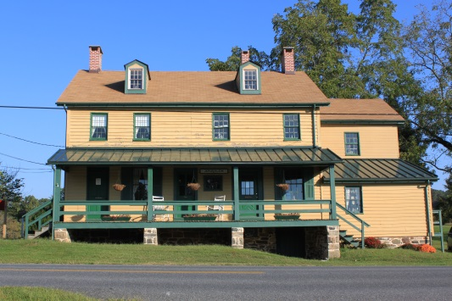

The General Store, Civil War Room and Gift Shop are open on Saturdays and Sundays from 1 p.m. to 4 p.m. Learn about the village’s connection to the Civil War, step into a 1930s general store, and browse our gift shop for a variety of souvenirs including items made by our own blacksmiths.

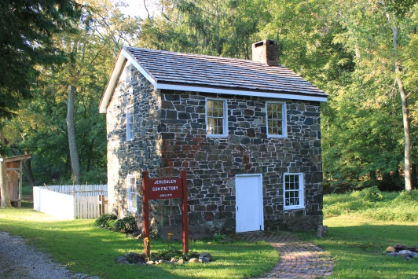

The Miller’s House (a.k.a. “the gun shop”) is open on Sundays from 1 p.m. to 4 p.m.. Watch costumed interpreters demonstrate hearth and open fire cooking, gardening, sewing or other activities of daily life in Colonial times.

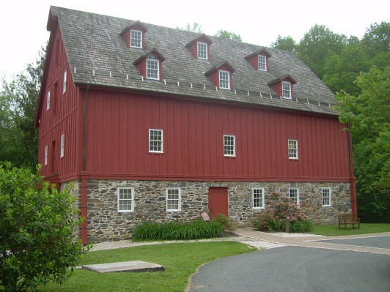

The Grist Mill (Visitor Center and Museum) is open on Saturdays and Sundays from 10 a.m. to 4 p.m., and Mondays and Fridays from 1 p.m. to 4 p.m.. Learn about the village, explore our artifacts, and see how a 1772 grist mill operated.

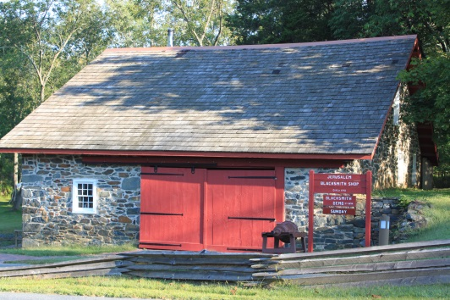

The Blacksmith Shop is open on the second Saturday of every month, from 1 p.m. to 4 p.m.. See the forge in operation as our blacksmiths demonstrate their trade.

Not pictured:
Located in the front room of the Carriage House, adjacent to the mill, is the Joinery where our colonial woodworker demonstrates the tools and techniques used in colonial times. The Joinery is open on Sundays from 2 p.m. to 4 p.m..
We are sincerely grateful to our sponsors for their generosity, enthusiasm, and belief in our mission! We encourage all of our visitors to patronize our sponsors’ quality services and products. To inquire about sponsoring our many activities and events, e-mail us at jerusalemmill@yahoo.com !

Welch Mechanical Designs, LLC
Designers and manufacturers of high-quality, high-precision optical systems for commercial, military and scientific applications.
1200 Technology Drive, Suite N
Aberdeen, MD 21001 410-698-3024

HCF&L P.A.
Handwerger, Cardegna, Funkhouser & Lurman, P.A. is a full service tax, accounting, and business consulting firm.
1104 Kenilworth Drive, Suite 300
Towson, MD 21204 410-828-0226

Sunshine Grille Bistro and Catering
Greek and American cuisine in a casually elegant atmosphere.
12607 Fork Road, Fork, MD 21051
410-592-3378

Wirtz & Daughters Garden Center
Visit us or use our delivery service for mulch, sand, soil, or stone products.
12140 Pulaski Highway, Joppa, MD 21085
410-679-6700 wirtzleahl@gmail.com

Walter G. Coale, Inc.
New Holland tractors, Mahindra tractors, Lawn care equipment, trailers and snow removal equipment for sale
2849 Churchville Rd, Churchville, MD, 21028 410-838-3500

TSW Roofing Solutions
1615 Robin Circle, Suite G
Forest Hill, MD 21050 410-979-7876

Joppatowne Garden Club
Perry Hall, MD 21128 410-698-5786

Friends of David Marks
Baltimore County Councilman
councilmanmarkscampaign@gmail.com

Lassahn Funeral Home
7401 Belair Rd, Baltimore, MD 21236
410-665-2000
hlassahn@lassahnfuneralhomes.com

Bel Air Dental Care
Alan Scharf, DDS and
Gregory Indyke, DDS
2300 Belair Road, Fallston, MD 21047
410-679-6700 or 410-879-8424

Corbin Fuel
Blue Ribbon pricing and service!
33 East Ellendale Street
Bel Air, MD 21014-0689
410-879-0579, 410-838-3590, or
1-800-474-3590

Reds Wine and Spirits
Catering, Deli, Prepared Foods, Butcher – Fresh Cut Meats, Wine, Beer, Liquor, Groceries, ATM, Lottery, Propane
12037 Belair Road, Kingsville, MD 21087
410-592-6202

It’s All Fun & Games Day Camp
Everything a camp should be!
Located in the Valleybrook Country Club
1810 Valleybrook Drive, Kingsville, MD, 21087 410-879-4460

Party Party
Your total party headquarters!
222 Commerce Road, Forest Hill, MD, 21050 410-893-3321

Gunpowder Lodge
Unique neighborhood restaurant & bar tucked alongside the Gunpowder River.
10092 Belair Road, Kingsville, MD 21087
410-256-2626

Feild Family Dentistry
Gentle Dental for the Whole Family
Dr. Paul E Feild, DDS, PA
12619 Harford Road, Fork, MD 21051
Pete’s Pickins Antiques and Collectables
Over 40 years of experience buying and selling quality antiques!
7901 Bradshaw Road,
Upper Falls, MD, 21156
410-592-6884 or 410-592-5420

Prosperity Home Mortgage, LLC
Put Prosperity in your life!
Joseph H. Bragg, III, Home Mortgage Consultant (NMLSR #209891)
3004 Emmorton Road, Abingdon, MD, 21009 410-515-6007

Harry and Scott Sanders
Long and Foster Realtors
Bringing a heritage of quality to Baltimore and Harford County real estate.
12514 Jerusalem Road, Kingsville, MD, 21087 410-592-6751

Maryland Army National Guard Recruiting and Retention NCO SGT Kimberly Kerschner
4244 Montgomery Rd
Ellicott City, MD 21043
443-789-9269
Kimberly.D.Kerschner.mil@mail.mil

The Flanders Group
Wealth Management, CPA,
and Tax Service
221 Maitland Street, Bel Air 21014
Telephone: 410-569-4506
Email: info@flanderscpa.com

Yox’s Yard
Small engine and lawn equipment maintenance
12210 Pulaski Hwy., Bldg C
Joppa, MD 21085 410-977-5511
Yoxs.Yard@gmail.com
Gallup Well Services
Well pumps, water treatment, pressure tanks, plumbing
Telephone: 410-321-7244
e-mail: brucehgallup@gmail.com
contact: Randall McGill

Cherokee Raiders
Non-profit organization; Western and English equestrian show series.
608 N. Tollgate Rd., Bel Air, MD
cherokeeraiders@gmail.com

Amateur Jousting Club of Maryland
e-mail: phoffman12@verizon.net

Bmore Electric LLC
Edgewood, MD 443-243-8464
Electricalcontractoredgewood.com

K.P. Hubers Produce Farms
7110 Mt. Vista Rd., Kingsvill, MD
410-593-9670

Dunk’n Donuts
1920 Belair Rd., Fallston, MD
410-877-2445

Chesapeake Nine of Baltimore
Vintage Baseball Team (19th century)
Contact: jtstanik@att.net
www.Mavbbl.com/capitol-conference/chesapeake-nine-of-baltimore/

Deerfield Electric Co., Inc.
Providing professional electrical services for more than 58 years.
7215 Sunshine Ave., Kingsville, MD 21087
www.deerfieldelectricco.com
410-592-7529

This newsletter is also supported by a grant from the Maryland State Arts Council and the Harford County Cultural Arts Board.

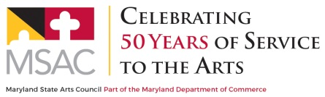
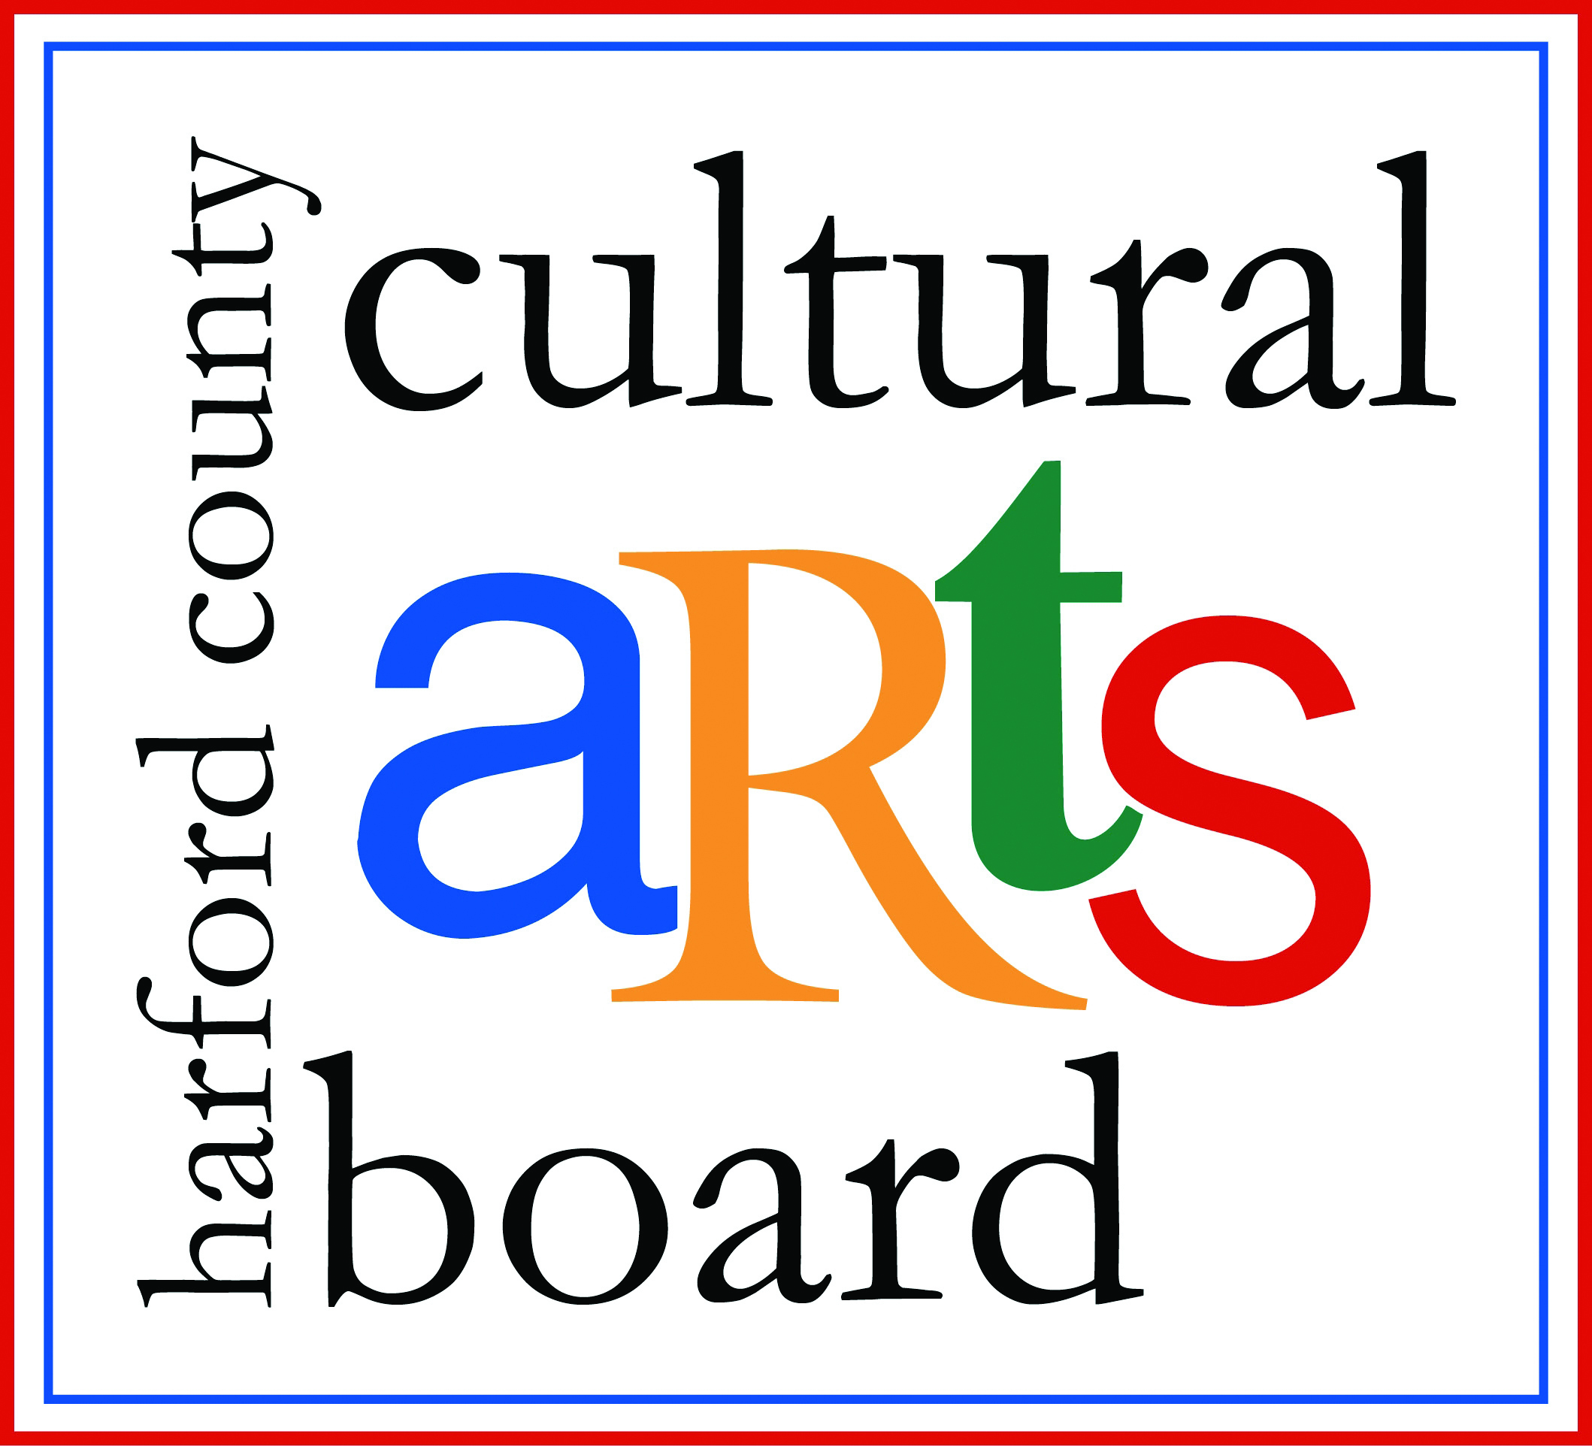

Special thanks to the Harford County Special Grants, Cultural Grants, and Office of Economic Development for their continued support!

